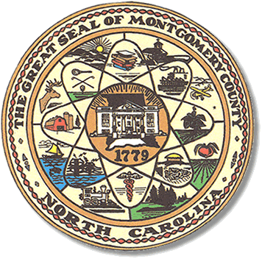

Montgomery County
Board of Elections

Karen Blair, Chairperson
John Adams, Vice Chair
Debbie Burris, Secretary

Dree Wynkoop, Member
Tasha Medley, Member

BOARD MEETING MINUTES
January 10, 2023
5:30 p.m.

The Montgomery County Board of Elections (BOE) met January 10, 2023 at
5:30 p.m. at the BOE Office at 327 Main St in Troy, NC. Present were: Dree Wynkoop, Debbie Burris, Tasha Medley, Karen Blair and John Adams. Also present was the Director of Elections, Rhonda Johnson and Deputy Director, Kim Batten.

Karen Blair asked the meeting to be called to order. John Adams gave the motion with a second from Dree Wynkoop.

The agenda was approved for meeting. Dree Wynkoop made the motion to approve the agenda and Tasha Medley seconded the motion. All were in favor.

The minutes from December 13 were amended. Also minutes from November 7, 8, and 18 were approved with a motion from Debbie Burris and a second from Dree Wynkoop. All were in favor.

Karen Blair, the chairperson, added a new item to the first of the year meeting agenda going forward: BOE Chair’s Notes, in which, she highlights some of BOE’s activities and accomplishments during the past year.

This year, Karen discussed things such as reinstituting Voter Registration drives, getting new voting equipment, dealing with an election protest and reinstating board members visiting voting sites on Election Day.

Another item that has been added to the monthly agenda is Director of Elections’ Report. Rhonda Johnson gave a short report on any issues, tasks, and State requests that the board should know about.
See attached.

There were no public comments.

Old Business
Protocol for Election Day Officials Selection was tabled until the February 2023 meeting.

New Business
Rhonda Johnson distributed the new calendar for 2023 with regular monthly meetings, absentee meeting dates, Hand Eye Audit, Election Canvass and County holidays.

Rhonda Johnson had all board members to sign the resolution to make Mt. Gilead Highlands Community Center the precinct for One Stop and Election voting.

It was decided the board would like Rhonda Johnson investigate getting a stamp with a “P” or “Provisional” on it to stamp provisional ballots.

With no further business at hand, and no other comments, Karen Blair called for a motion to adjourn. Debbie Burris moved to adjourn the meeting with a second from Dree Wynkoop. All were in favor and the meeting was adjourned at 6:26 p.m.

________________________________________ CHAIR

________________________________________ VICE CHAIR

________________________________________ MEMBER

________________________________________ MEMBER

________________________________________ MEMBER
Montgomery County Board of Elections

