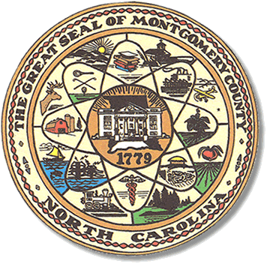

Montgomery County
Board of Elections

BOARD MEETING AGENDA
TUESDAY, DECEMBER 12, 2023
5:30 pm

Call to Order

Approval of minutes since election

Approval of the Agenda

Director of Elections’ Report

Old Business

Recruiting young voters and new precinct officials

Public Comment Period (5 minutes at the podium)

New Business

Candidate filing status.

2024 Calendars

2024 Meeting schedule

Resolution from NCSBOE

Adjournment

**ALL BOE Meetings to be held in the Montgomery County Board of Elections office unless otherwise noted.

