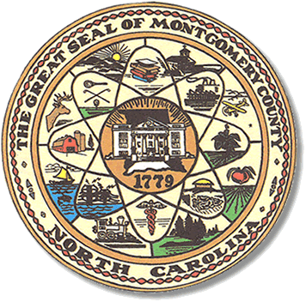

Montgomery County
Board of Elections

BOARD MEETING AGENDA
MONDAY, MARCH 15, 2024
9:00 am

Call to Order

Approval of minutes

Approval of the Agenda

Director of Elections’ Report

Old Business

None

Public Comment Period (5 minutes at the podium)

New Business

Provisional Ballot approval

Supplemental Absentees

Adjournment

**ALL BOE Meetings to be held in the Montgomery County Board of Elections office unless otherwise noted.

