**Montgomery County**

**Board of Elections**

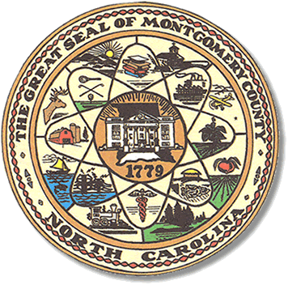

BOARD MEETING AGENDA

TUESDAY, FEBRUARY 13, 2024

5:00pm

Call to Order

Approval of minutes

Approval of the Agenda

Director of Elections’ Report

**Old Business**

**Public Comment Period (5 minutes at the podium)**

**New Business**

Absentee ballot approval

Zoom meetings /you tube

Website

Agenda’s posted

Visits to precincts

November Election Workers (teachers)

Recruiting Workers

Update on student assistants

Getting out the vote

**Adjournment**