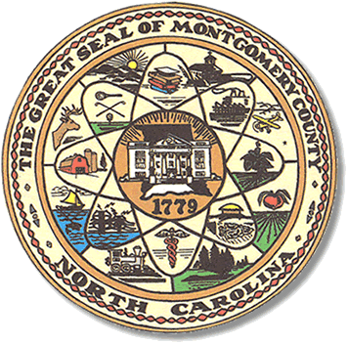

**Montgomery County**

**Board of Elections**



### 

### 

BOARD MEETING AGENDA

AUGUST 13, 2024

5:30PM

Call to Order

Approval of minutes

Approval of the Agenda

Directors Report

**Old Business**

Hearing Update

**Public Comment Period (5 minutes at the podium)**

**New Business**

Precinct workers for fall discussion

Deputy Director

Law Books

Absentee Meeting Handout

Closed session meeting

Adjournment

**ALL BOE Meetings to be held in the Montgomery County Board of Elections office unless otherwise noted.