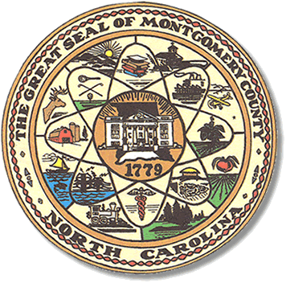

Montgomery County
Board of Elections

BOARD MEETING AGENDA
TUESDAY, APRIL 9, 2024
5:30 pm

Call to Order

Approval of minutes since election

Approval of the Agenda

Director of Elections’ Report

Old Business

Look at past meeting minutes, approval and signing.

Public Comment Period (5 minutes at the podium)

New Business

Discuss the March primary.

Adjournment

**ALL BOE Meetings to be held in the Montgomery County Board of Elections office unless otherwise noted.

