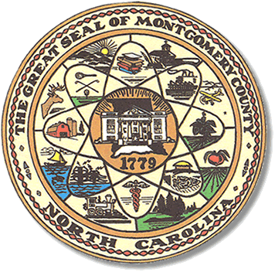

Montgomery County
Board of Elections

BOARD MEETING AGENDA
TUESDAY, FEB 9, 2021
5:30PM

Call to Order

Approve past minutes

HAVA funds coming to county.

Municipal Greeter & Safety budget

Voting booths & Vote here signs

Public Comments

