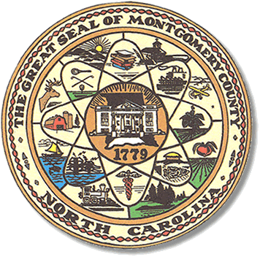

Montgomery County
Board of Elections
, Chairman (vacant)
Rosemary K. Huntley, Secretary

John J. Adams, Member

MONTGOMERY COUNTY BOARD OF ELECTIONS
BOARD MEETING
AGENDA

April 17, 2018
5:00 P.M.

Call to Order

Public Comment Period

Approval of minutes.

Review of absentee ballots.

Memos from the SBOE

Adjournment

**ALL BOE Meetings to be held in the Montgomery County Courthouse, BOE Office, Room 101, unless otherwise noted.

