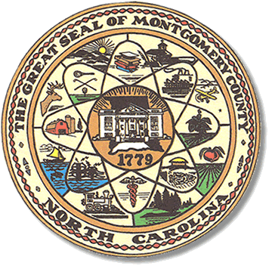

Montgomery County
Board of Elections

John Adams, Chairman
Mary Cagle, Vice Chair

Curtis Carter, Member

Dree Wynkoop, Member

BOARD MEETING AGENDA
WEDNESDAY, DECEMBER 12, 2018
5:30 P.M.

Call to Order

Public Comment Period

Approval of Nov , 2018 minutes

Move of BOE office

State Board of Elections Dissolution.

Other

Adjournment

**ALL BOE Meetings to be held in the Montgomery County Courthouse, BOE Office, Room 101, unless otherwise noted.

