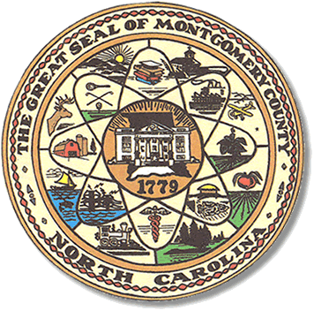

Montgomery County
Board of Elections

BOARD MEETING AGENDA
TUESDAY, JULY 21 2020
5:30pm

Call to Order

Public Comment Period

One Stop locations.

Adjournment

There will be a closed door personnel meeting immediately following the regular BOE meeting on the 21st.

**ALL BOE Meetings to be held in the Montgomery County Board of Elections office unless otherwise noted.

