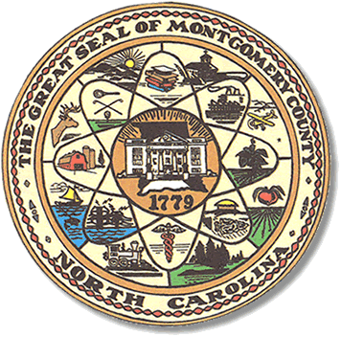

Montgomery County
Board of Elections

BOARD MEETING AGENDA
TUESDAY, JANUARY 16, 2024
5:30 pm

Call to Order

Approval of minutes

Approval of the Agenda

Director of Elections’ Report

Old Business

Resolution from NCSBOE early voting workers

Public Comment Period (5 minutes at the podium)

New Business

Precinct Official Training

High school poll workers

Election Law changes 2024

Pilot plan absentee signature verification

Website

Adjournment

**ALL BOE Meetings to be held in the Montgomery County Board of Elections office unless otherwise noted.

