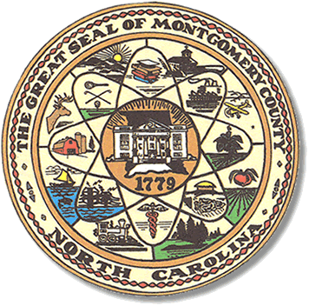

Montgomery County
Board of Elections

BOARD MEETING AGENDA
WEDNESDAY, JANUARY 13, 2021
5:30PM

Call to Order

Approve past minutes

Resolution for Director

Discuss calendar for year 2021

Precinct complaints / issues.

Public Comments

**ALL BOE Meetings to be held in the Montgomery County Board of Elections office unless otherwise noted.

