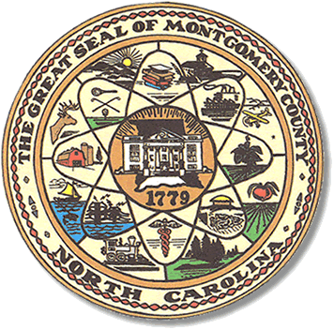

**Montgomery County**

**Board of Elections**



### 

### 

BOARD MEETING AGENDA

TUESDAY, OCTOBER 27, 2020

5:00pm

Call to Order

Approval of minutes

Absentee Ballot Approval

Adjournment

Public Comments (2 min.)

**ALL BOE Meetings to be held in the Montgomery County Board of Elections office unless otherwise noted.