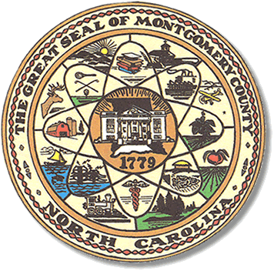

Montgomery County
Board of Elections

Mary Cagle, Chairman
John Adams, Vice Chair

Curtis Carter, Member

Dree Wynkoop, Member

BOARD MEETING AGENDA
TUESDAY, JUNE 12, 2018
5:30 P.M.

Call to Order

Public Comment Period

Approval of May meeting minutes

Soil & Water

Resign abstract

Other

Adjournment

**ALL BOE Meetings to be held in the Montgomery County Courthouse, BOE Office, Room 101, unless otherwise noted.

