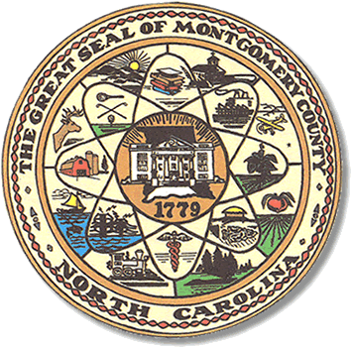

Montgomery County
Board of Elections

Mary Cagle, Chairman
John Adams, Vice Chair

Curtis Carter, Member

Dree Wynkoop, Member

BOARD MEETING AGENDA
TUESDAY, MAY 7, 2018
5:00 P.M.

Call to Order

Public Comment Period

Approval of May 1st meeting minutes

Approve absentee ballots

Observers

Ophir voters

Other

Adjournment

**ALL BOE Meetings to be held in the Montgomery County Courthouse, BOE Office, Room 101, unless otherwise noted.

