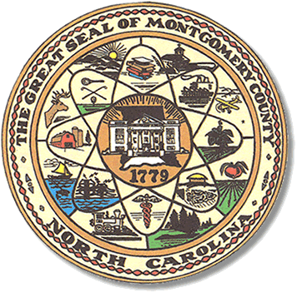

Montgomery County
Board of Elections

CONFERENCE CALL BOARD MEETING AGENDA
TUESDAY, APRIL 14, 2020
5:30pm

Call to Order

Discuss the closing of the county offices

Discuss the safety procedures due to Corona virus.

Adjourn

**ALL BOE Meetings to be held in the Montgomery County Board of Elections office unless otherwise noted.

