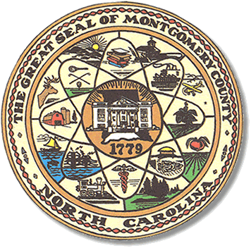

Montgomery County
Board of Elections

Mary Cagle, Chairman
John Adams, Vice Chair

Curtis Carter, Member

Dree Wynkoop, Member

BOARD MEETING AGENDA
Tuesday, AUGUST, 2018
5:30 PM

Call to Order

Public Comment Period

Approval of minutes from July 17th.

State Board of Elections approved our One Stop Plan.

Update on the assigned poll workers participation.

Fire tax in Wadeville Fire District

Absentee by mail starts September 7, 2018.

Security of the office.

Adjournment

**ALL BOE Meetings to be held in the Montgomery County Courthouse, BOE Office, Room 101, unless otherwise noted.

