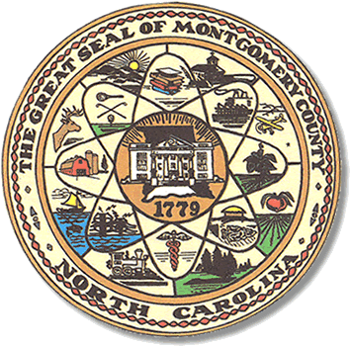

Montgomery County
Board of Elections

BOARD MEETING AGENDA
TUESDAY, FEBRUARY 25, 2020
5:00pm

Call to Order

Public Comment Period

Approval of minutes

Approve absentee ballots.

**ALL BOE Meetings to be held in the Montgomery County Board of Elections office unless otherwise noted.

