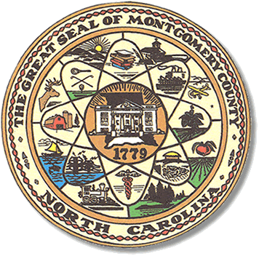

Montgomery County
Board of Elections

Karen Blair, Chairperson
John Adams, Vice Chair
Debbie Burris, Secretary

Dree Wynkoop, Member
Tasha Medley, Member

BOARD MEETING MINUTES
November 7, 2022
5:00 p.m.

The Montgomery County Board of Elections (BOE) met Tuesday, Nov 7, 2022 at
5:00 p.m. at the BOE Office at 327 Main St in Troy, NC. Present were: Dree Wynkoop, Debbie Burris, Karen Blair, Tasha Medley and John Adams. Also present was the Director of Elections, Rhonda Johnson and Deputy Director Kim Batten.

Karen Blair called the meeting to order at 5:02 p.m.

Dree Wynkoop motioned to approve the agenda with a second from Tasha Medley. All were in favor.

The minutes from November 1th were approved with a motion from Dree Wynkoop, and a second from Tasha Medley.

Old Business
None

There were no public comments.

New Business
Absentee Ballots – There were a total of 49 civilian and 3 military Absentee Ballots. There were 49 civilian ballots approved and 3 military ballots approved. Dree Wynkoop motioned to approve the ballots with a second from John Adams. All were in favor.

John Adam noted as of today 160 total absentees have been approved.

With no further business at hand, and no other comments Debbie Burris moved to adjourn the meeting with a second from Tasha Medley. All were in favor and the meeting was adjourned at 5:47 p.m.

________________________________________ CHAIR

________________________________________ VICE CHAIR

________________________________________ MEMBER

________________________________________ MEMBER

________________________________________ MEMBER
Montgomery County Board of Elections

