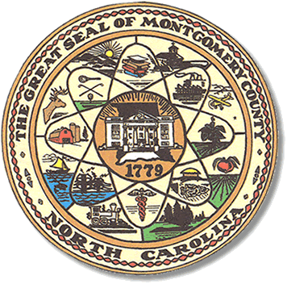

Montgomery County
Board of Elections

Teddi Benson Chairperson
John Adams, Secretary
Debbie Burris, Member

Dree Wynkoop, Member
Tasha Medley, Member

BOARD MEETING MINUTES
October 31, 2023
5:00 p.m.

The Montgomery County Board of Elections (BOE) met October 31, 2023, at
5:00 p.m. at the BOE Office located at 327 N. Main St in Troy, NC. Present were Dree Wynkoop, Debbie Burris, Teddi Benson, John Adams and Tasha Medley. Also present was Rhonda Johnson Director of Elections and Kim Batten, Deputy Director.

Teddi Benson, chairperson called the meeting to order at 5:02 pm.

There are no minutes to approve.

The agenda was approved for the meeting. Dree Wynkoop made the motion to approve the agenda and Debbie Burris seconded the motion. All were in favor.

Old Business

Official not showing up for training. Letha Dumas did not show up for training. She was called and sent letters. John Adams suggested pulling from One Stop group. First, they would ask Tselane Legrande, who is serving as the democratic judge if she would move up to Chief Judge.

New Business

There were no ballets returned.

There were request from new chief judges to have assistants’ available election day. John Adams did not think it would be busy enough during municipal election to warrant having assistances. If each precinct had one experience poll worker that should be enough. The decision was put to a vote. Teddi called for a motion. John Adams gave the motion and Tasha Medley seconded it.

With no further business at hand, and no other comments, Teddi Benson called for a motion to adjourn. Debbie Burris moved to adjourn the meeting with a second from Dree Wynkoop. All were in favor and the meeting was adjourned at 5:31 p.m.

The board then went into closed session,

________________________________________ CHAIR

________________________________________ SECRETARY

________________________________________ MEMBER

________________________________________ MEMBER

________________________________________ MEMBER
Montgomery County Board of Elections

