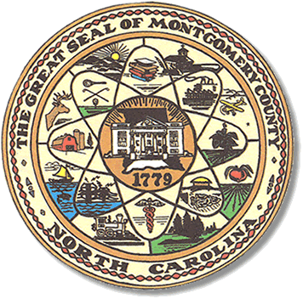

Montgomery County
Board of Elections

Teddi Benson Chairperson
John Adams, Secretary
Debbie Burris, Member

Dree Wynkoop, Member
Tasha Medley, Member

BOARD MEETING MINUTES
November 7, 2023
5:00p.m.

The Montgomery County Board of Elections (BOE) met November 7, 2023, at
5:00 p.m. at the BOE Office located at 327 N. Main St in Troy, NC. Present were Dree Wynkoop, Debbie Burris, Teddi Benson, John Adams and Tasha Medley. Also present was Rhonda Johnson, Director of Elections Kim Batten, Deputy Director.
Teddi Benson, chairperson called the meeting to order at 5:00 pm.

There are no minutes to approve.

The agenda was approved for the meeting. Dree Wynkoop made the motion to approve the agenda and Tasha Medley seconded the motion. All were in favor.

Old Business
none

New Business

One ballot was returned and approved. A total of 6 ballots have been approved.

With no further business at hand, and no other comments, Teddi Benson called for a motion to adjourn. Dree Wynkoop moved to adjourn the meeting with a second from Tasha Medley. All were in favor and the meeting was adjourned at 5:37 p.m.

________________________________________ CHAIR

________________________________________ SECRETARY

________________________________________ MEMBER

________________________________________ MEMBER

________________________________________ MEMBER
Montgomery County Board of Elections

