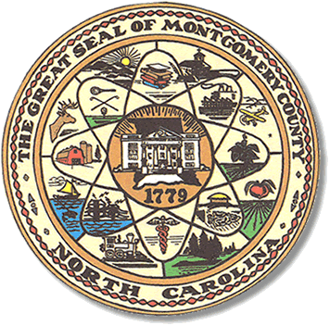

Montgomery County
Board of Elections

Teddi Benson Chairperson
John Adams, Secretary
Debbie Burris, Member

Dree Wynkoop, Member
Tasha Medley, Member

BOARD MEETING MINUTES
October 24, 2023
5:00p.m.

The Montgomery County Board of Elections (BOE) met October 24, 2023, at
5:00 p.m. at the BOE Office located at 327 N. Main St in Troy, NC. Present were Dree Wynkoop, Debbie Burris, Teddi Benson, John Adams and Tasha Medley. Also present was Kim Batten, Deputy Director and Rhonda Johnson, Director.

Teddi Benson, chairperson called the meeting to order at 5:02 pm.

There are no minutes to approve.

The agenda was approved for the meeting. Dree Wynkoop made the motion to approve the agenda and Debbie Burris seconded the motion. All were in favor.

Old Business

There is no old business.

New Business

There was one ballet returned and one ballot approved.

The director’s yearly evaluation is due by 11/14/2023. The final copy is due to the county manager on 12/12/2023.

Tasha Medley reminded the board that she wanted a closed meeting. The board agreed to closed session on 10/31/2023 after the absentee meeting.

Teddi told the board about looking on the election website for the county and not being able to click on the minutes, it would not open. Rhonda advised the board that she would reach out to IT about the button not opening. She told the board that she had never had any training and had been given a small booklet to read about how to use the website. She explained the website does not always work correctly.

The board also wanted to start having the meetings taped.

With no further business at hand, and no other comments, Teddi Benson called for a motion to adjourn. Debbie Burris moved to adjourn the meeting with a second from Dree Wynkoop. All were in favor and the meeting was adjourned at 5:41 p.m.

________________________________________ CHAIR

________________________________________ SECRETARY

________________________________________ MEMBER

________________________________________ MEMBER

________________________________________ MEMBER
Montgomery County Board of Elections

