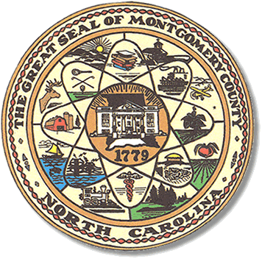

Montgomery County
Board of Elections

Mary Cagle, Chairman
John Adams, Vice Chair
Demond Hairston, Secretary

Dree Wynkoop, Member
Debbie Burris, Member

BOARD MEETING MINUTES
PROVISIONAL & CANVASS MEETING
November 17, 2023
10:00am

The Montgomery County Board of Elections met Friday, November 17, 2023, at 10:00am at the BOE Office at 327 Main St in Troy, NC. Present were Dree Wynkoop, Debbie Burris, Teddi Benson, Tasha Medley and John Adams. Also present was the Director of Elections, Rhonda Johnson, and Deputy Director Kim Batten.

Teddi Benson called the meeting to order at 10:00am

There are no minutes to approve for this meeting.

The agenda was approved for the meeting. John Adams made the motion to approve the agenda and Dree Wynkoop seconded the motion. All were in favor.

Public Comment Period (5 minutes at the podium)

With reference to Election Day, Rosa Little stated that “some people were turned away when they did not have their ID.” Andrea Marshall, who was serving as Chief Judge for Mt. Gilead precinct explained to the board there had been 2 people who left and returned with their ID and voted.

The board reviewed provisional ballots. There were 14 ballots to be reviewed. There were 5 approved, 9 rejected.

Rhonda took the provisional ballots and entered all the information into Seims.
Then processed all the provisional voters in Seims.

Once all that was completed Rhonda printed the reports for the board to sign to finalize
The canvass of all the votes in the 2023 Municipal Election.

With no further business at hand, and no other comments, Teddi Benson called for a motion to adjourn. Dree Wynkoop moved to adjourn the meeting with a second from Debbie Burris. All were in favor and the meeting was adjourned at 11:40 a.m.

________________________________________ CHAIRMAN

________________________________________ VICE CHAIR

________________________________________ SECRETARY

________________________________________ MEMBER

________________________________________ MEMBER
Montgomery County Board of Elections

