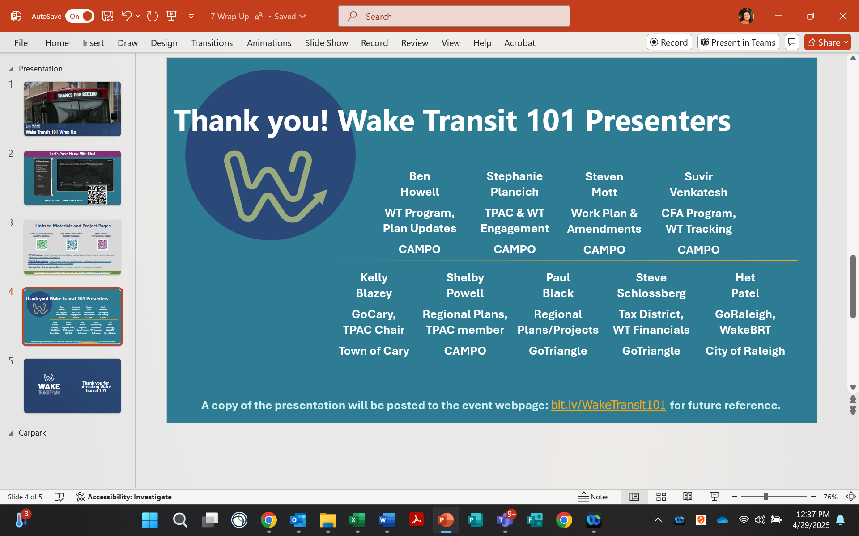

Ben Howell ben.howell@campo-nc.us
Stephanie Plancich stephanie.plancich@campo-nc.us
Steven Mott steven.mott@campo-nc.us
Suvir Venkatesh suvir.venkatesh@campo-nc.us
Shelby Powell shelby.powell@campo-nc.us
Kelly Blazey kelly.blazey@carync.gov
Paul Black pblack@gotriangle.org
Steven Schlossberg sschlossberg@gotriangle.org
Het Patel het.patel@raleighnc.gov

