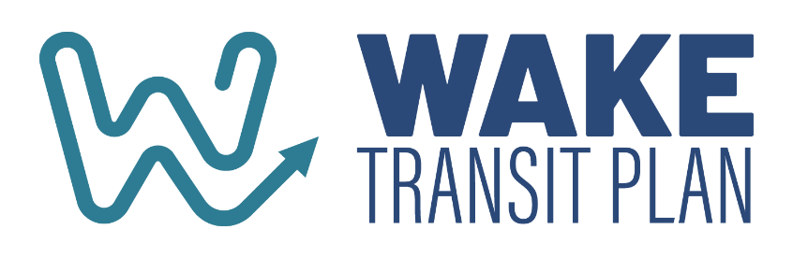
Wake Transit 101 Agenda
April 30, 2025 • 1:30-4:30pm
Hybrid Event
In-person at CAMPO: 1 Fenton Main, Ste 201, Cary NC 27511
Listen In via WebEx: https://campo-nc.webex.com/campo-nc/j.php?MTID=m09419a076636af182188e0d984b96486

Welcome and Introductions | Kelly Blazey, Cary/TPAC Chair
Section 1: Connecting to Local, Regional and State Planning
Regional and Statewide Coordination | Shelby Powell, CAMPO
Informing Local Planning | Het Patel, City of Raleigh
Section 2: Wake Transit’s Origin Story and Financial Plan
Pre-Wake Regional Planning History | Paul Black, GoTriangle
Developing the Wake Transit Plan | Ben Howell, CAMPO
Section 3: Guidance and Authority
Interlocal Governance Agreement | Ben Howell, CAMPO
Tax District Administration | Steve Schlossberg, GoTriangle/TDA
Master and Other Agreements | Ben Howell, CAMPO
Section 4: Plans, Policies and Studies
Wake Transit Plan Wake Bus Plan | Ben Howell, CAMPO
Wake Bus Plan/Sort-Range Transit Plans | Ben Howell, CAMPO
Annual Wake Transit Work Plan | Steven Mott, CAMPO
Community Funding Area Program | Suvir Venkatesh, CAMPO
Other Policies and Studies | Ben Howell, CAMPO
Section 5: Community Engagement
Wake Transit Branding Update, Engagement Policy, Evaluation and Improvements | Stephanie Plancich, CAMPO
Section 6: Tracking and Reporting
Annual and Quarterly Reports | Ben Howell, CAMPO
Other Performance Reporting | Steven Mott, CAMPO
Wake Transit Performance Tracker | Suvir Venkatesh, CAMPO
Section 7: Wrap Up
Wrap up poll, contact list and program links | Kelly Blazey, Cary/TPAC Chair

