Social Media Content
Coordinated Public Transit-Human Services Transportation Plan Update
February/March 2024
Date | Platform | Post | Image/s
Feb. 2 | Twitter  Facebook | Help improve public transit in the Capital region. Visit https://PublicInput.com/CoordinatedPlan2024 to complete a short online survey. Stop by a popup table near YOU next Tuesday and Wednesday.  Learn More: https://PublicInput.com/CoordinatedPlan2024  #CoordinatedPlanUpdate | 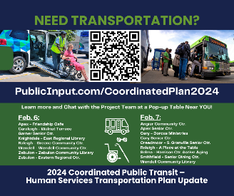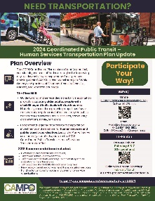
Feb. 2 | Instagram | Help improve public transit in the Capital region. Visit https://PublicInput.com/CoordinatedPlan2024 to complete a short online survey. Stop by a popup table near YOU next Tuesday and Wednesday.  Learn More: https://PublicInput.com/CoordinatedPlan2024  #CoordinatedPlanUpdate | 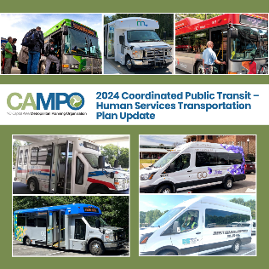
Feb. 5 | Twitter  Facebook  Instagram | El Plan Coordinado del 2024 busca identificar estrategias prácticas, sostenibles y rentables para mejorar la movilidad/transporte diario para todas las personas que residen dentro del área jurisdiccional de CAMPO (todo el condado de Wake y partes de Chatham, Franklin, Granville, Harnett, y Johnston).  ¡Participa a tu manera!  Encuesta En línea: https://Publicinput.com/CAMPOcommunitysurvey_espanol  O escanea este código QR  Eventos emergentes:  6 y 7 de febrero  ¡Más de 10 ubicaciones!  Su participación ayuda a garantizar que el Plan represente mejor las necesidades de transporte y movilidad dentro de la región de CAMPO. | 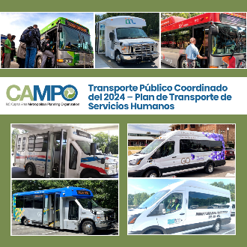
Feb. 6 | Twitter  Facebook  Instagram | Live in or around Apex, Cary, Garner, Knightdale, Raleigh, Wendell or Zebulon*? Share your ideas and opinions for improving public transportation! The project team for the Coordinated Plan Update will be in each of these jurisdictions TODAY! And there will be more TOMORROW, too! Details at https://PublicInput.com/CoordinatedPlan2024  #CoordinatedPlanUpdate  *@XXX(List Town handle/s) – USE TOWN/CITY SOCIAL HANDLES IN THE MESSAGE TEXT | 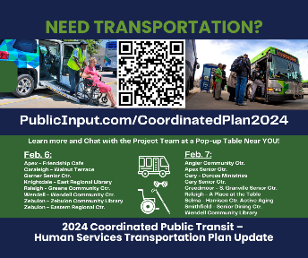
Feb. 7 | Twitter  Facebook | Live in or around Angier, Apex, Cary, Creedmoor, Raleigh, Selma, Smithfield or Wendell?* Share your ideas and opinions for improving public transportation! The project team for the Coordinated Plan Update will be in each of these jurisdictions TODAY! And there will be more TOMORROW, too! Details at https://PublicInput.com/CoordinatedPlan2024  #CoordinatedPlanUpdate  *@XXX(List Town handle/s) – USE TOWN/CITY SOCIAL HANDLES IN THE MESSAGE TEXT | 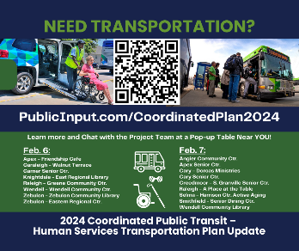
Feb. 8 | Twitter  Facebook  Instagram | Have an idea or suggestion for improving transportation services for seniors, low-income individuals, and persons with disabilities? CAMPO is listening. Take the short survey today!  https://PublicInput.com/CoordinatedPlan2024  #CoordinatedPlanUpdate | YOUTUBE:  Crystal Video – Find on Digital Toolkit
Feb. 14 | Twitter  Facebook  Instagram | Live in a one-car household? Is the lack of affordable transportation alternatives a challenge for you? Learn about low-cost transportation services available throughout the Capital region. Details at https://PublicInput.com/CoordinatedPlan2024  ¡La encuesta esta en Español!  #CoordinatedPlanUpdate | 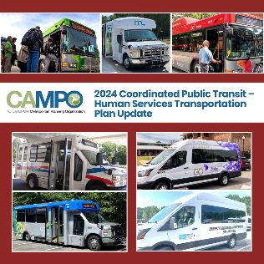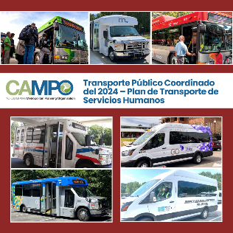
Feb. 21 | Twitter  Facebook  Instagram | Have you taken the survey about public transit that is coordinated across our region to meet human service needs – for seniors, persons with low-incomes, disabled persons, etc.? Do it now! Transit agencies across the region have joined together to update the region’s Coordinated Plan and your input is important! Visit https://PublicInput.com/CoordinatedPlan2024  ¡La encuesta esta en Español!  #CoordinatedPlanUpdate | 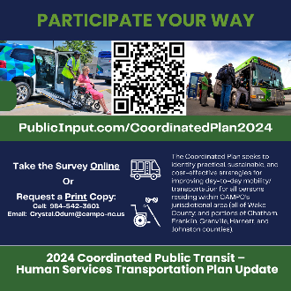QR Codes in English and Spanish
3/X (last few days before survey is closing | Twitter  Facebook  Instagram | Only 2 days left to take the survey about the region’s public transit and human services transportation system. You need to be a part of this conversation!  ¡La encuesta esta en Español!  #CoordinatedPlanUpdate | 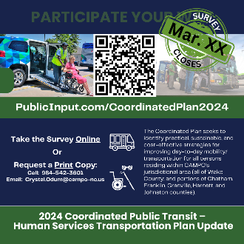 QR Codes in English and Spanish

