Social Media Content
Wake BRT: Rapid Bus Extensions Study
Draft: March 21, 2022
Date | Platform | Post | Image
4/5 | Facebook, Twitter, Instagram | What could rapid transit look like between Garner and Clayton or between Cary and RTP? Provide your input on alignment alternatives for the Wake BRT: Rapid Bus Extensions Study! Learn about the findings from phase 1, explore the updated virtual open house, and provide your input today at WakeBRTExtensionsStudy.com  #WakeBRTExtensions #ExtendWakeBRTSouth #ExtendWakeBRTWest | Website Graphic  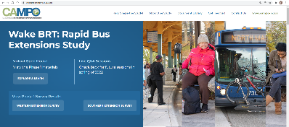  **Update graphic once new website design is launched**
4/12 | Facebook, Twitter, Instagram | The #ExtendWakeBRTWest study is underway, and needs your input to help decide on the alternatives. Visit the virtual open house today and take the survey to share your input.  WakeBRTExtensionsStudy.com | Western Overview Graphic  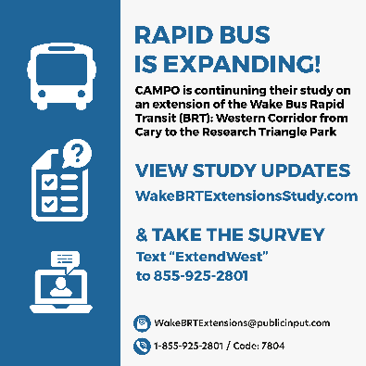
4/14 | Facebook, Twitter, Instagram | Provide your thoughts on the alternatives for the #ExtendWakeBRTSouth study. Visit the virtual Open house and take the survey to share your input.  WakeBRTExtensionsStudy.com | Southern Overview Graphic  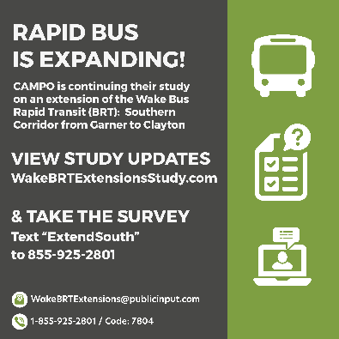
4/19 | Facebook, Twitter, Instagram | We are thinking about the future and your input in needed. The #ExtendWakeBRTWest study is underway. Visit the virtual open house today and take the survey to share your input.  #WakeBRTExtensions | Western Meeting Graphic
4/20 | Facebook, Twitter, Instagram | We are planning ahead and your input in needed. The #ExtendWakeBRTSouth study is underway. Visit the virtual Open house and take the survey to share your input.  #WakeBRTExtensions | Southern Meeting Graphic
4/29 | Facebook, Twitter, Instagram | Live, work, or travel to #Cary #Morrisville #RTP #Garner or #Clayton? Don’t miss the opportunity to help shape transit in your community. Today is your last chance to take the Wake BRT: Rapid Bus Extensions Study surveys. ¿Hable español? ¡La encuesta está disponible en español! #ExtendWakeBRTWest #ExtendWakeBRTSouth  #WakeBRTExtensions  WakeBRTExtensionsStudy.com | Survey Graphic  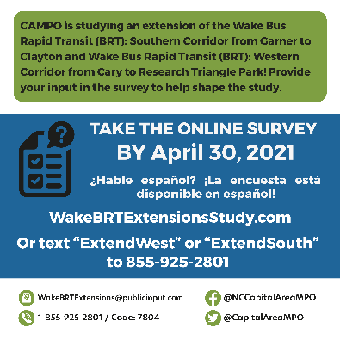
IF NEEDED | Facebook, Twitter, Instagram | Happening Tonight! Join the live virtual Q&A session at 6 p.m. to hear from the #ExtendWakeBRTWest study team and ask questions about the proposed Western Corridor Rapid Bus Extension study. For meeting access information, visit WakeBRTExtensionsStudy.com. | Western Meeting Graphic  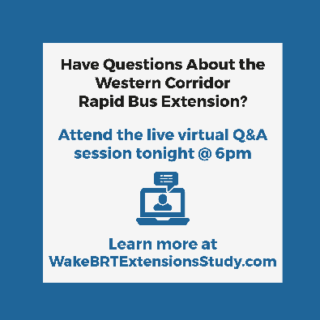
IF NEEDED | Facebook, Twitter, Instagram | Happening Tonight! Join the live virtual Q&A session at 6 p.m. to hear from the #ExtendWakeBRTSouth study team and ask questions about the proposed Southern Corridor Rapid Bus Extension study. For meeting access information, visit WakeBRTExtensionsStudy.com. | Southern Meeting Graphic  