Date | Platform | Post | Graphic
April 23 | Facebook  X  Instagram | North Harnett County is growing, and exploration of mobility options, including transit, are underway to better support the community.  The N.C. Capital Area Metropolitan Planning Organization and Harnett County have launched the North Harnett Transit Study. Join us on a journey to evaluate the support and need for public transit in northern Harnett County, and make recommendations for transit service options based on feasibility and input from the public, elected officials, and other stakeholders.  Learn more at www.northharnetttransitstudy.com  #NorthHarnettTransit | 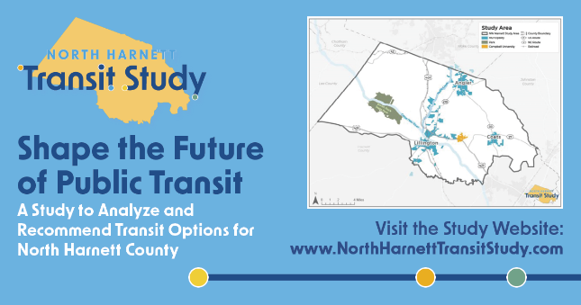
May 1 | Facebook  X | The Study seeks your input on the needs and goals for public transit services to create a community vision for transit in North Harnett County.  Take our survey online, by visiting  https://www.northharnetttransitstudy.com/engage  #NorthHarnettTransit | 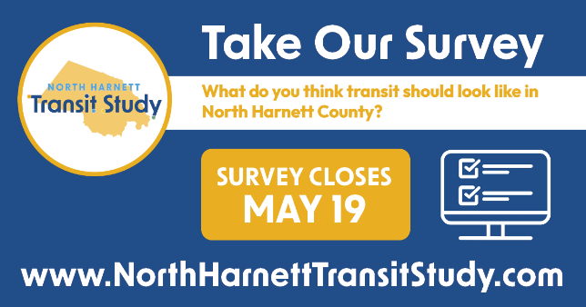
May 8 | Facebook  X | What is public transit? Public transit means transportation that everyone in a community can use together. It includes things like buses, shuttles, or shared rides.  What does public transit look like? Discover the possibilities with the North Harnett Transit Study at  www.northharnettransitstudy.com/learn  #NorthHarnettTransit
May 14 | Facebook  X | There’s still time to share your vision for public transit in North Harnett County! Our online survey is live until Sunday, May 19.  To take our survey, visit  https://www.northharnetttransitstudy.com/engage  #NorthHarnettTransit
Anytime | Facebook  X | Join the Study Team at EVENT. It’s being held on DATE at LOCATION at TIME.  We want to hear from you! How do you currently travel around? What do you think transit should look like in North Harnett County?  For more event details, visit  https://www.northharnetttransitstudy.com/engage  #NorthHarnettTransit | 