Date | Platform | Post | Graphic
Mar. 15, 2025 | Instagram | The North Harnett County Transit Study evaluated the need and support for transit in the northern half of Harnett County.  The study recommends pursuing Microtransit with regional connections to nearby destinations to support the community’s transportation needs.  Microtransit is a mix of traditional bus service and ridesharing.  Learn more about microtransit and how it can benefit you at www.northharnetttransitstudy.com/microtransit  #NorthHarnettTransit | 
3/20, 2025 | Instagram | The Study seeks your input on Microtransit, the newly recommended transit service for North Harnett County.  Share your comments online today, by visiting www.northharnetttransitstudy.com/engage  The comment period will end on Monday, April 14, 2025.  #NorthHarnettTransit | 
3/25/2025 | Instagram | Do you have questions about Microtransit? Attend the virtual “Ask a Planner” event on Wednesday, April 9, to hear from Study planners and discover the possibilities of Microtransit.  For more information on how to attend, visit: www.northharnetttransitstudy.com/events  The comment period will end on Monday, April 14, 2025.  #NorthHarnettTransit | 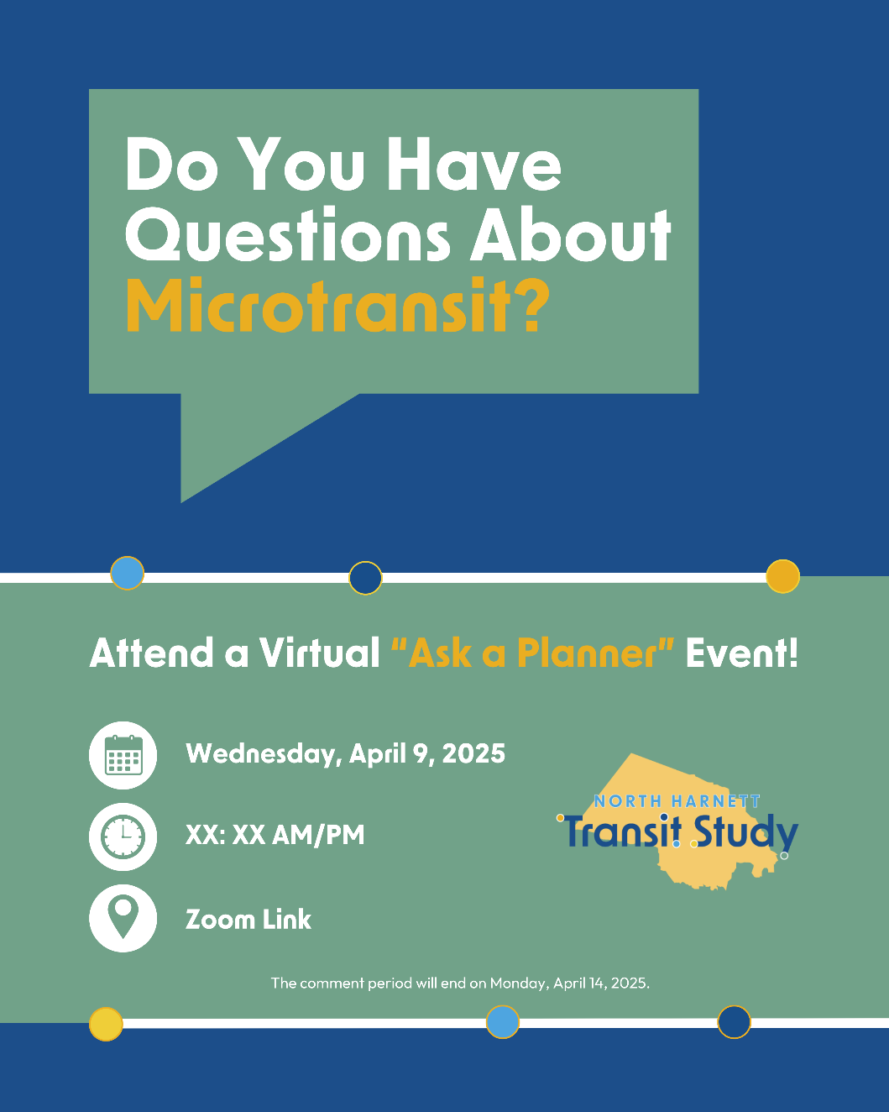
3/30/2025 | Facebook | The North Harnett County Transit Study evaluated the need and support for transit in the northern half of Harnett County.  The study recommends pursuing Microtransit with regional connections to nearby destinations to support the community’s transportation needs.  Microtransit is a mix of traditional bus service and ridesharing.  Learn more about microtransit and how it can benefit you at www.northharnetttransitstudy.com/microtransit  #NorthHarnettTransit | 
4/6, 2025 | Facebook | The North Harnett Transit Study seeks your input on Microtransit, the newly recommended transit service for North Harnett County.  Share your comments online today, by visiting www.northharnetttransitstudy.com/engage  The comment period will end on Monday, April 14, 2025.  #NorthHarnettTransit | 
4/2 & 4/9 (AM), 2025 | Facebook | Do you have questions about Microtransit? Attend the virtual “Ask a Planner” event on Wednesday, April 9, to hear from Study planners and discover the possibilities of Microtransit.  For more information on how to attend, visit: www.northharnetttransitstudy.com/events  The comment period will end on Monday, April 14, 2025.  #NorthHarnettTransit | 