**FOR IMMEDIATE RELEASE March 27, 2025**

Contact: Bonnie Parker, Public Engagement & Communications

984-542-3604 or [bonnie.parker@campo-nc.us](mailto:bonnie.parker@campo-nc.us)

**MICROTRANSIT WITH CONNECTIONS TO REGIONAL DESTINATIONS   
RECOMMENDED FOR HARNETT COUNTY, N.C.**

*North Harnett Transit Study Seeks Community Input on Transit Recommendations*

**Harnett County, N.C. –** The proposed transit solution for one of our region’s highest growth areas is **microtransit with connections to regional destinations**, per the [North Harnett Transit Study](https://www.northharnetttransitstudy.com/). Launched in November 2023 by the N.C. Capital Area Metropolitan Planning Organization (CAMPO) and Harnett County, the study has evaluated the public’s need and support for transit in the portion of northern Harnett County, N.C. that overlaps with the CAMPO boundary, including Angier, Lillington, Coats, Buies Creek, Raven Rock State Park, and Campbell University.

**Microtransit with Regional Connections**

Based on community feedback and transit/demographic data, the proposed recommendation is a hybrid model: Microtransit within a proposed service area combined with connections to or from a set of nearby destination options. This would include three Park & Rides north of Harnett County that provide connections to existing transit services in Wake County, as well as popular services and shopping centers to the south.

**More on Microtransit**

Microtransit combines traditional bus service with ridesharing, allowing riders to travel anywhere within the **service area**. All of this on their own schedule! Users request a ride in real-time using a smartphone app, website, or phone call. It's flexible, convenient, reliable, and open to everyone!

**Community feedback needed**

“Microtransit is like having a personal ride service you can book through an app on your phone,” Gaby Lawlor, Sr. Transportation Planner at CAMPO. “It's flexible and easy, letting you travel on your own schedule to reach multiple destinations in this growing rural area. We need feedback from the community about microtransit and the proposed service area to help our study team finalize the implementation plan."

The [North Harnett Transit Study](http://www.northharnetttransitstudy.com) has launched a public comment period and events where study team members can be found at community places to discuss the proposal, answer questions, and gain feedback. This will help finalize study recommendations and inform local officials on implementation efforts. The study’s [website](https://www.northharnetttransitstudy.com/) provides information about microtransit and its benefits, allows the public to share feedback via the **survey** form, sign up for updates, and explore upcoming events, including a **virtual “Ask A Planner” event on Wednesday, April 9, 2025. The comment period is open now through Monday, April 14, 2025.**

Beyond this study, additional planning will be needed before operation can begin. Based on public input, transit demand, and feedback from officials and stakeholders, the study is developing an implementation plan to help outline those future steps for the proposed transit services in Harnett County.

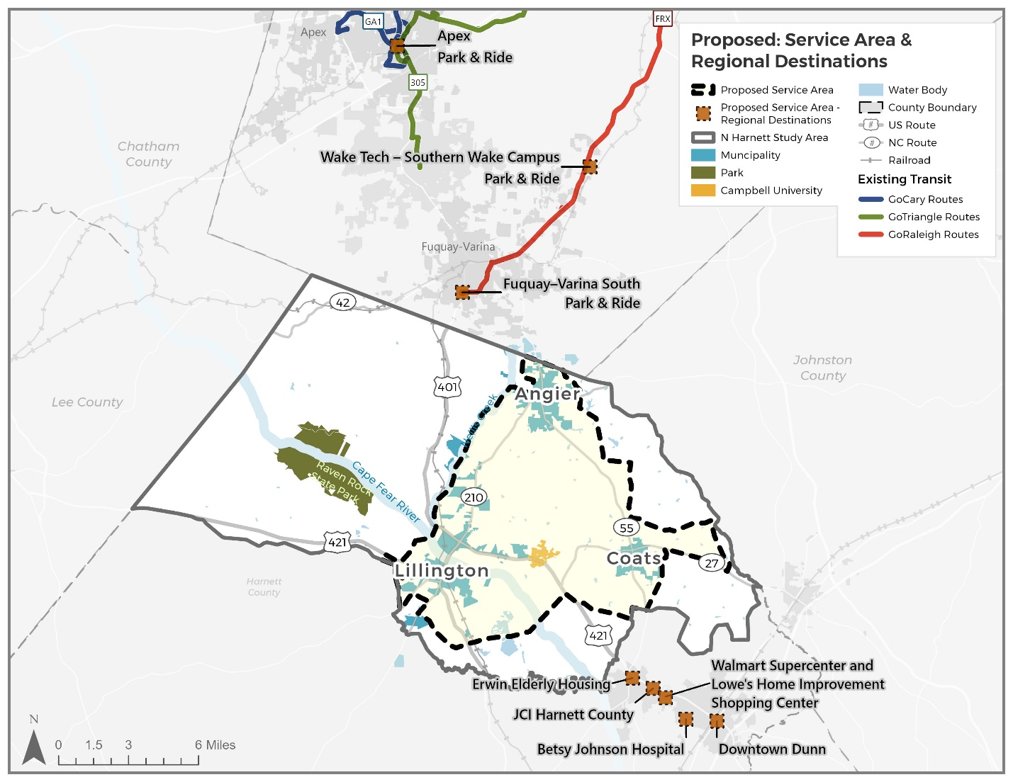

**About N.C. Capital Area Metropolitan Planning Organization (CAMPO):**

[CAMPO](https://www.campo-nc.us/) is a regional transportation planning organization serving communities in Franklin, Granville, Harnett, Johnston, and Wake Counties. CAMPO serves as the coordinating agency between local governments, the North Carolina Department of Transportation, the Federal Transit Administration, and the Federal Highway Administration.

###