Email Subject Line: New Transit Service Recommended for Harnett County – Your Input Needed
Email Body:
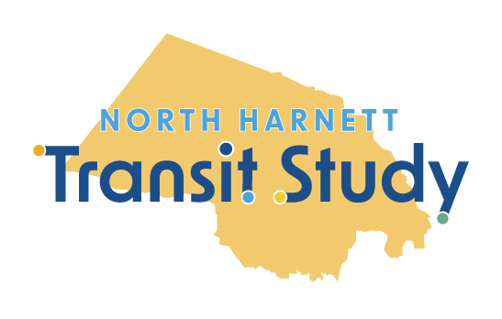

Microtransit with Connections to Regional Destinations Recommended for Harnett County

Share Your Thoughts at Upcoming Events, Comment Form
The North Harnett Transit Study proposed transit solution for one of our region’s highest growth areas is microtransit with connections to regional destinations. Launched in November 2023 by the N.C. Capital Area Metropolitan Planning Organization (CAMPO) and Harnett County, the study has evaluated the public’s need and support for transit in the portion of northern Harnett County, N.C. that overlaps with the CAMPO boundary, including Angier, Lillington, Coats, Buies Creek, Raven Rock State Park, and Campbell University.

Microtransit with Regional Connections
Based on community feedback and transit/demographic data, the proposed recommendation is a hybrid model: Microtransit within a proposed service area combined with connections to or from a set of nearby destination options. This would include three Park & Rides north of Harnett County that provide connections to existing transit services in Wake County, as well as popular services and shopping centers to the south.

More on Microtransit
Microtransit combines traditional bus service with ridesharing, allowing riders to travel anywhere within the service area. All of this on their own schedule! Users request a ride in real-time using a smartphone app, website, or phone call. It's flexible, convenient, reliable, and open to everyone!

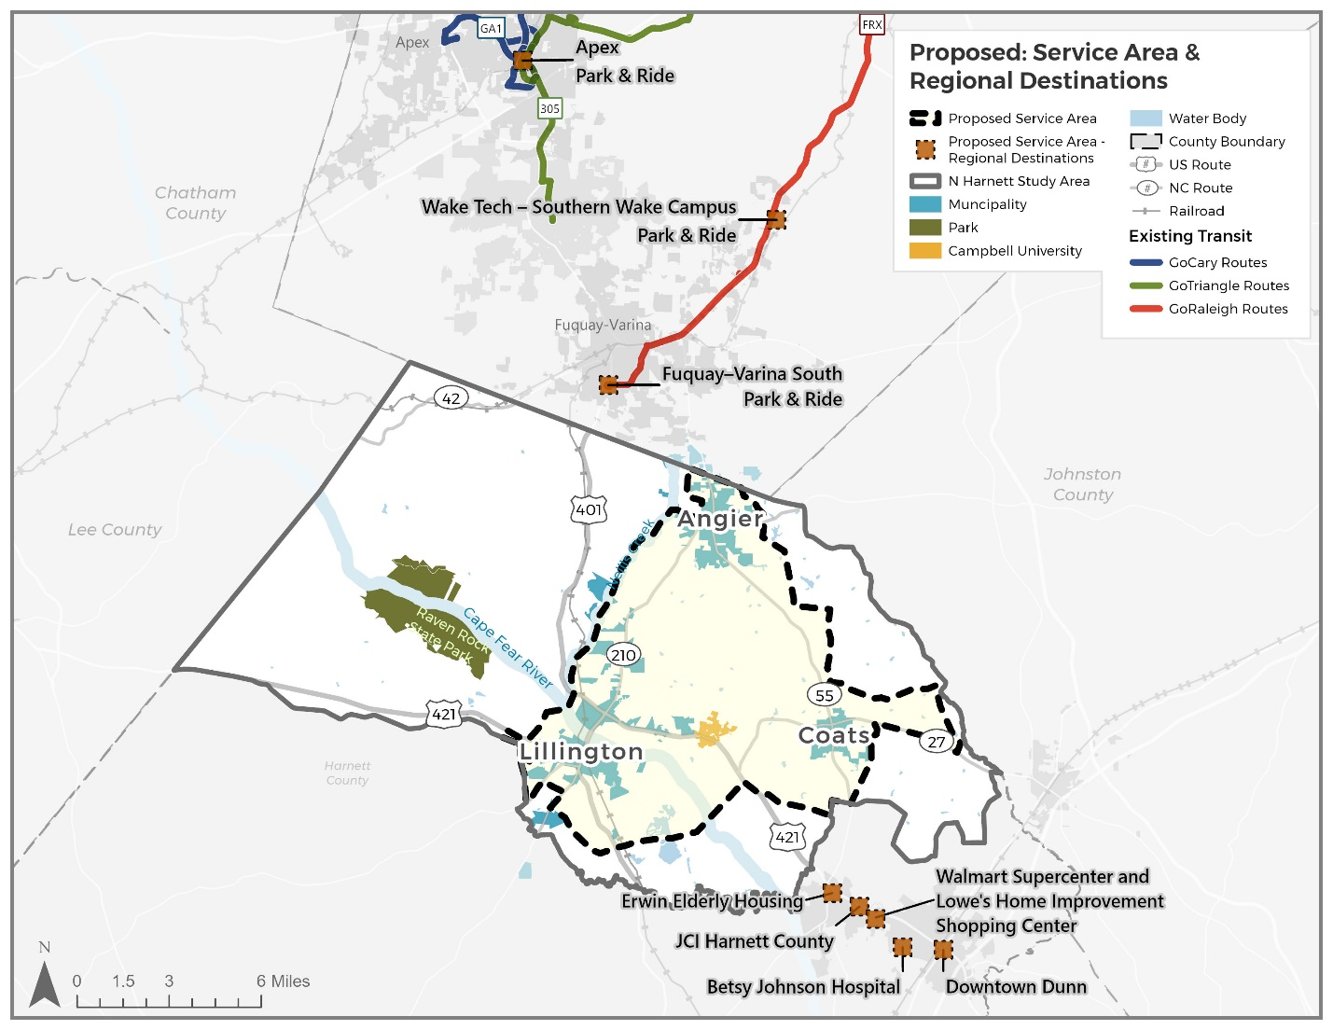

Your Feedback is Needed
The North Harnett Transit Study has launched a public comment period and events where study team members can be found at community places to discuss the proposal, answer questions, and gain feedback. This will help finalize study recommendations and inform local officials on implementation efforts.

How to Get Involved
- Visit the Study’s Website: Learn more about microtransit and its benefits.
- Share Your Feedback: Use the comment form on the website to share your feedback on the proposed transit solution. The comment period is open now through Monday, April 14, 2025.
- Sign Up for Updates: Stay informed about upcoming events and the study’s progress.
- Attend Community Events: Participate in upcoming study events, including a virtual “Ask A Planner” event on Wednesday, April 9, 2025. Visit the study website for more details.

Study Schedule Update
Beyond this study, additional planning will be needed before operation can begin. Based on public input, transit demand, and feedback from officials and stakeholders, the study is developing an implementation plan to help outline those future steps for implementing the proposed transit services in Harnett County.
Visit the study website for a full schedule update.
Questions or comments about the North Harnett Transit Study?
Contact the Study Team today!
Contact Button + Link

Email Footer:
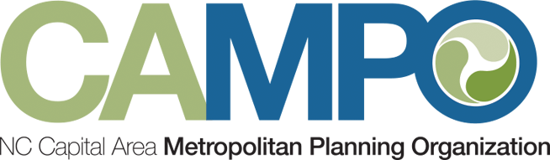
Link logo to Website Link logo to Website
Facebook Icon & Link Facebook Icon & Link
Twitter Icon & Link Twitter Icon & Link
Instructions on how to unsubscribe from email list.

