Social Media Content
U.S. 401 Corridor Study
Revised: October 10, 2023
Date | Platform | Post | Image
October 12 | Twitter  Facebook  Instagram | The #US401CorridorStudy team is hosting three public meetings: 1) Tuesday, Oct. 17 between 5:30-7:30 PM at the Harnett Co. Administration Building in Lillington; 2) Monday, Oct. 23 from 5-7 PM at Fuquay Varina Town Hall; 3) Thursday, Oct. 26 at 4PM Online. Talk with the study team and provide your input. More at www.US401CorridorStudy.com | 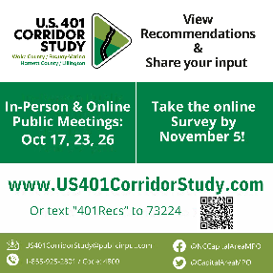
October 17 | Twitter  Facebook  Instagram | Reminder that the #US401CorridorStudy is hosting a public meeting tonight at the Harnett Co. Administration Building in Lillington! The team will share proposed transportation recommendations and answer questions between 5:30-7:30 PM. Can’t make it? Visit www.US401CorridorStudy.com to view the meeting materials and online survey.
October 20/21 | Twitter  Facebook  Instagram | The #US401CorridorStudy online survey is open! Visit www.US401CorridorStudy.com or text keyword 401Recs to 73224 to provide your input about proposed transportation improvements for existing U.S. 401, and for the Future U.S. 401. ¿Hable español? ¡La encuesta está disponible en español! | 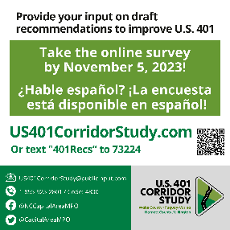
October 23 | Twitter  Facebook  Instagram | Reminder that the #US401CorridorStudy is hosting a public meeting tonight at Fuquay Varina Town Hall, located at 134 N. Main Street! The team will share proposed transportation recommendations and answer questions between 5-7 PM. Can’t make it? Visit www.US401CorridorStudy.com to view the meeting materials and online survey.
October 25 | Twitter  Facebook  Instagram | The #US401CorridorStudy is hosting a study update presentation tonight at 7:00 PM at Town Hall in Angier, located at 55 N. Broad Street. The team will brief attendees on the study’s proposed transportation recommendations. This presentation is open to the public! Can’t make it? Visit www.US401CorridorStudy.com to view the meeting materials and online survey.
October 26 | Twitter  Facebook  Instagram | Reminder that the #US401CorridorStudy is hosting an ONLINE Ask a Planner event today at 4 PM! The study team will share proposed transportation recommendations and answer questions. The Webex link is posted on the project website. Can’t make it? Visit www.US401CorridorStudy.com to view the meeting materials and online survey.
October 29/30 | Twitter  Facebook  Instagram | This week is the last chance to take the #US401CorridorStudy survey! Visit www.US401CorridorStudy.com or text keyword 401Recs to 73224 to provide your input on the potential future alignments for the corridor. ¿Hable español? ¡La encuesta está disponible en español!
November 5 | Twitter  Facebook  Instagram | Today is the last day to provide your input on draft recommendations in the #US401CorridorStudy survey! Hurry and share your feedback! Visit www.US401CorridorStudy.com or text keyword 401Recs to 73224 to fill out the short survey about potential future alignments for the corridor. ¿Hable español? ¡La encuesta está disponible en español!

INSTA
@harnett_county
@wakegov
@townoffuquayvarina
@lillingtonnc
@townofangier

FACEBOOK
Harnett County Government
WakeCounty Gov
Town of Fuquay-Varina
Town of Lillington, NC
Town of Angier, NC

