FOR IMMEDIATE RELEASE: October 11, 2023
News Media Contact: Bonnie Parker: 984-542-5604 or Bonnie.Parker@campo-nc.us
U.S. 401 Corridor Study Seeks Public Input on Recommendations
WAKE AND HARNETT COUNTIES, N.C. — The U.S. 401 Corridor Study team is seeking input on proposed recommendations for transportation improvements to U.S. 401 as it exists today in southern Wake and northern Harnett Counties, as well as a new roadway, known as Future U.S. 401, in southern Wake County. Public participation has been critical throughout the study process, with this being the fourth round of public engagement. The study team is asking members of the community who live, work, or travel in southern Wake (including Fuquay-Varina) or northern Harnett counties (including Angier and Lillington), to review the recommendations and provide feedback to help develop final recommendations.

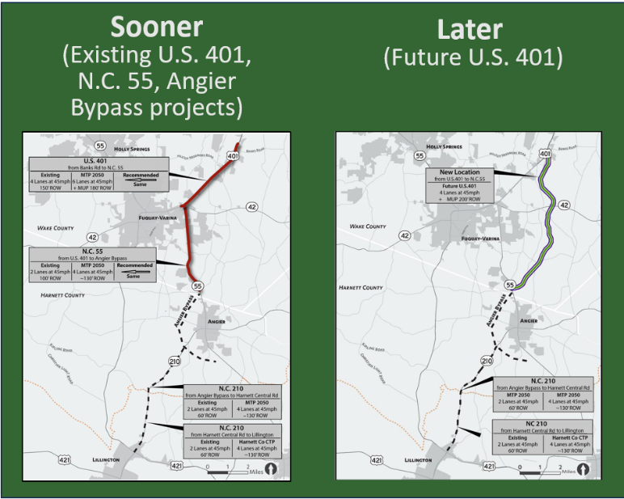
The study area includes approximately 19 miles of U.S. 401 from Banks Road in Wake County south through the Town of Fuquay-Varina to the N.C. 210 and U.S. 421 intersection near the Town of Lillington in Harnett County; and about seven miles for the future U.S. 401. Public input received in the Fall of 2021 helped to develop potential improvements to existing U.S. 401, as well as provided input on initial alignment options for the Future U.S. 401. Engagement during the Fall of 2022 focused on three potential alignments for a Future U.S. 401. In addition, significant technical analysis has been conducted over the past two years. The results from these efforts can be found on the project website.

Major Study Recommendation:
Improvements to Existing U.S. 401 and other existing area roadways should be prioritized for short and mid-term implementation – to occur before the long-term recommendation for a new roadway, known as “Future U.S. 401”.

Public Meetings
The Study team is hosting two drop-in style public meetings. The first on Tuesday, October 17, 2023, from 5:30-7:30 p.m. at Harnett County Administration Building in Lillington, located at 455 McKinney Parkway, and the second on Monday, October 23rd, from 5-7 p.m. at the Fuquay Varina Town Hall, located at 134 N. Main Street. These drop-in style meetings will provide an opportunity to learn about the study’s progress, and review and provide feedback on the proposed recommendations. The website will host all presentation materials.

Study Website: www.US401CorridorStudy.com
Public meeting materials will be available on the study website, as well as the results from previous public input. Interested individuals can also sign up on the website for future email updates about the study.

Study Survey
In addition to the public meetings, a survey will be used to gather input from community members to assist in the development of the final recommendations for the study. The survey will be open through November 5. It can be accessed through the study website, via text message, as well as in print. To participate via text, text the keyword “401Recs” to 73224 to begin the survey. Contact the project team to request a print survey, if needed.

Questions
The project team is available to answer questions. Send an email to US401CorridorStudy@PublicInput.com or call 1-855-925-2801 and enter code 4800 when prompted. For #US401CorridorStudy updates follow CAMPO on Facebook, Twitter, or Instagram.

Accommodations:
Persons who require Americans with Disabilities Act (ADA) assistance to attend the meeting, review website materials, or take the online survey should call or email Bonnie Parker at 984-542-3604 or bonnie.parker@campo-nc.us no later than 48 hours before the event.

Persons who speak Spanish and do not speak English, or have a limited ability to read, speak or understand English, may receive interpretive services upon request prior to the meeting by calling Bonnie Parker at 984-542-3604. Aquellas personas que hablan español y no hablan inglés, o tienen limitaciones para leer, hablar o entender inglés, podrían recibir servicios de interpretación si los solicitan antes de la reunión llamando Bonnie Parker al 984-542-3604.

###

