FOR IMMEDIATE RELEASE: November 22, 2022
News Media Contact: Bonnie Parker: 919-996-4403 or Bonnie.Parker@campo-nc.us
U.S. 401 Corridor Study Seeks Public Input on Alignment Options
RALEIGH, N.C. — The U.S. 401 Corridor Study team is seeking input on potential alignment options for the Future U.S. 401. Public participation is critical at this step in the study process. The Study team is asking members of the community who live, work, or travel in southern Wake or northern Harnett counties to review the alignment options and provide feedback to help develop final recommendations.

The study area includes approximately 19 miles of U.S. 401 from Banks Road in Wake County south through the Town of Fuquay-Varina to the N.C. 210 and U.S. 421 intersection near the Town of Lillington in Harnett County; and about seven miles for the future U.S. 401. Public input received in the Fall of 2021 helped to develop potential improvements to the existing U.S. 401, as well as provided input on initial alignment options for the Future U.S. 401. The results from these efforts can be found on the project website.

In March of 2022, following a presentation on an initial assessment of five U.S. 401 alignment options, the CAMPO Executive Board gave direction to continue with analysis of the three alternatives with the least potential impacts. Having completed the additional analysis, the study’s project team will present information about the three potential future alignments at the upcoming public meetings to seek public input.

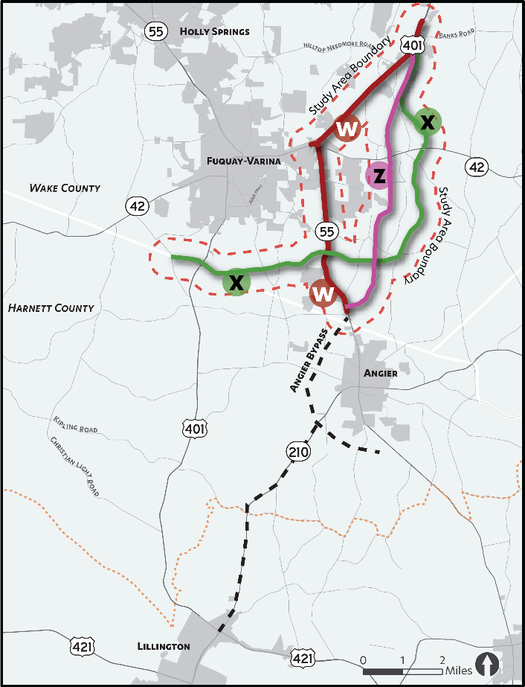

Public Meetings
The Study team is hosting two drop-in style public meetings. The first on Tuesday, December 6, 2022, from 5-7 p.m. at Fuquay Varina Town Hall, located at 134 N. Main Street, and the second on Thursday, December 8, 2022, from 5-7 p.m. at the Harnett County Administration Building in Lillington, located at 455 McKinney Parkway. These drop-in style meetings will provide an opportunity to learn about the study’s progress, review the potential alignments for the Future U.S. 401, ask questions and provide input to help the project team develop the study recommendations The website will host all presentation materials.

Study Website: www.US401CorridorStudy.com
Public meeting materials will be available on the study website, as well as the results from previous public input. Interested individuals can also sign up on the website for future email updates about the study.

Study Survey
In addition to the public meetings, a survey will be used to gather input from community members to assist in the development of the final recommendations for the study. The survey will be open through December 16. It can be accessed through the study website, via text message, as well as in print. To participate via text, text the keyword “US401Corridor2” to 73224 to begin the survey. Contact the project team to request a print survey, if needed.

Questions
The project team is available to answer questions. Send an email to US401CorridorStudy@PublicInput.com or call 1-855-925-2801 and enter code 8961 when prompted. For #US401CorridorStudy updates follow CAMPO on Facebook, Twitter, or Instagram.

Accommodations:
Persons who require Americans with Disabilities Act (ADA) assistance to attend the meeting, review website materials, or take the online survey should call or email Bonnie Parker at 919-996-4403 or bonnie.parker@campo-nc.us no later than 48 hours before the event.

Persons who speak Spanish and do not speak English, or have a limited ability to read, speak or understand English, may receive interpretive services upon request prior to the meeting by calling Bonnie Parker at 919-996-4403. Aquellas personas que hablan español y no hablan inglés, o tienen limitaciones para leer, hablar o entender inglés, podrían recibir servicios de interpretación si los solicitan antes de la reunión llamando Bonnie Parker al 919-996-4403.

###

