Month | Platform | Post | Graphic
June – 21 CAMPO Blueprint Reel and Survey Post | Facebook  X  Instagram  LinkedIn | Have you thought of ways to make our roadways safer? You can help! CAMPO’s Blueprint for Safety is seeking YOUR input to identify problem roadway challenges, behaviors, places, and opportunities. Take the survey, learn more at publicinput.com/blueprintforsafety | 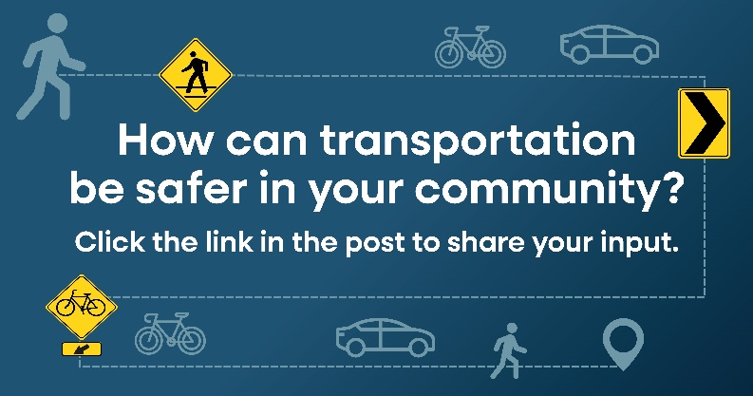  POST #1  ALT TEXT: Image of direction signs, icons of pedestrian, bicycle, vehicle, with text stating, "How can transportation be safer in your community? Click the link in the post to share your input." HTTPS://publicinput.com/blueprintforsafety  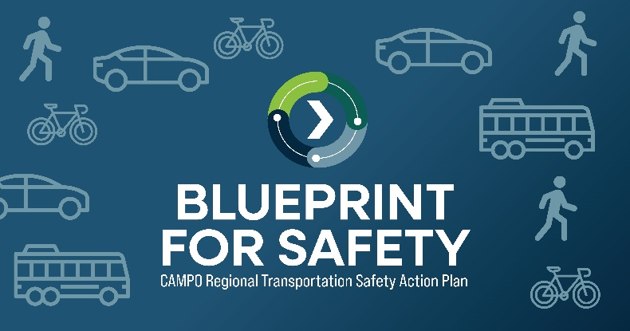  ALT TEXT: Logo in blues and greens for the Blueprint for Safety project with icons of pedestrians, bicycles, cars, buses/shuttles.
June – 25 CAMPO Blueprint Message | Facebook  X  Instagram  LinkedIn | Share the road, share the responsibility! CAMPO, @ncdotcom, and cities, towns within @chathamcountync @franklincountync @granvillecountync @harnett_county  @jocogovnc and @wakegov are working together to create a regionwide Blueprint for Safety. This plan will focus on solutions that we can use in our area to improve safety for all users – drivers, pedestrians, and bicyclists.  https://publicinput.com/blueprintforsafety  @nhtsagov @federalhighwayadmin @ncdotcom | REEL #1  ALT TEXT: Reel encouraging people to go to https://publicinput.com/blueprintforsafety to learn more about the Blueprint for Safety and take the online survey.
July – General Safety Message Options | Facebook  X  Instagram  LinkedIn | Celebrate July 4th responsibly! Booze It And Lose It. As we gather to celebrate our country’s independence, lets make a commitment to keep our roads safe. For more information, visit https://www.campo-nc.us/programs-studies/blueprint-for-safety about regional efforts to improve transportation safety for everyone.  July 15th-19th is national Rural Road Safety Awareness Week. Work with CAMPO and (Town/County) to prevent rural roadway departures. Learn more at https://www.campo-nc.us/programs-studies/blueprint-for-safety and https://ruralsafetycenter.org/ | 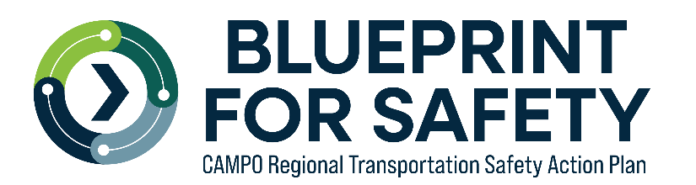
July – CAMPO Blueprint Message | Facebook  X  Instagram  LinkedIn | Your voice matters! CAMPO’s Blueprint for Safety is seeking community opinions to identify problems and opportunities to make our roads safer. Take the survey and learn more at https://publicinput.com/blueprintforsafety
August – CAMPO Blueprint Reel and Survey Post | Facebook  X  Instagram  LinkedIn | Make a difference in (Town/County)’s road safety! CAMPO’s Blueprint for Safety survey closes in August and we need YOUR feedback to identify road safety issues and solutions. Voice your concerns and ideas today at https://publicinput.com/blueprintforsafety
August – CAMPO Blueprint Message | Facebook  X  Instagram  LinkedIn | CAMPO, NCDOT, and (Town/County) are working together to create a regionwide Blueprint for Safety, and we need YOUR insight! Help us identify problem areas and opportunities to make our roads safer for everyone. For more information, visit https://www.campo-nc.us/programs-studies/blueprint-for-safety Let’s work together to make our roads safer!

 | NHTSA | FHWA | NCDOT
Facebook | https://www.facebook.com/NHTSA | https://www.facebook.com/FederalHighwayAdmin | https://www.facebook.com/NCDOT
X | https://x.com/nhtsagov | https://x.com/USDOTFHWA | https://x.com/ncdot
Instagram | https://www.instagram.com/nhtsagov/ | https://www.instagram.com/federalhighwayadmin/ | https://www.instagram.com/ncdotcom/

