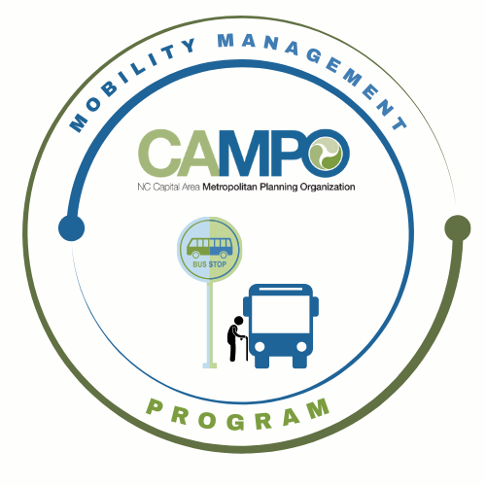
Mobility Coordination Committee (MCC)
CT Sub-committee Meeting Friday, May 22, 2026 – 11:00 am – 12:30 pm

Coordinated Public Transit - Human Services Transportation Plan

CT Meeting Minutes

- Welcome/ Introductions/Attendance – Anita Davis, CT Sub-Committee Chair
Anita Davis, Paris Butler, Natalie Wilson (GoWake Access), Sarah Keach, Jacob Irving, Suvir Venkatesh (CAMPO), Neal Davis (JCATS), Sean Abrams (GoRaleigh), Sheri Legans (GoCary), Pamela Bennett (HARTS), Chris Baucom (ADA), Rico Greene (GoTriangle)

- Meeting Minutes– Anita Davis, CT Sub-Committee Chair
Approved, no questions

- Action Item Recap – Anita Davis, CT Sub-Committee Chair

  - April Meeting Recap
    - Reviewed three new goals for July – December; Natalie updated the assessment sheets to reflect new goals.
  - Public Input – Meeting in June to discuss
  - Working with Bonnie from CAMPO to set up meeting

- Implementation Schedule –Anita Davis, CT Sub-Committee Chair
- Review Schedule to create January – December 6-month Work Plan
  - Goal: Review Work tasks (3)
    - 3.2.6 Identify dedicated funding mechanisms for rural transit agencies.
      - Anita developed a matrix of funding opportunities that can be found on SharePoint. Suggested thinking about what projects could be useful for each funding mechanism. Anita suggested closing out this goal, but committee decided to keep it ongoing as there will be different funding opportunities in the future.
    - 3.2.7 Expand service hours and days in rural areas as warranted.
      - Considered a work in progress as we collect survey data from different agencies
3.2.8 Continue to expand public transportation access in eastern Wake County

- Considered a work in progress.

- Mobility Coordination/Management Program Updates – Sarah Keach, MM
- Presentation at NCAMPO
  - Sarah gave recap of NCAMPO presentation
- Announcements - Anita Davis, CT Sub-Committee Chair
- Action Items for Next Meeting:
    - Transit Agencies - GoRaleigh, GoCary, GoTriangle, JCATS, HARTS -Please send Sarah Keach your ADA service area shapefiles if you have not already done so.
    - GoRaleigh, GoTriangle, JCATS - Please send Natalie Wilson any relevant survey data about service expansions or studies that justify expansions.

- Next meetings:

MCC CT Subcommittee Meeting: Friday, June 12th, 2026 11:00pm – 12:30pm
MCC ADA Subcommittee Meeting: Friday, June 12th, 2026 9:30am – 11am
MCC Quarterly Meeting: TBD

