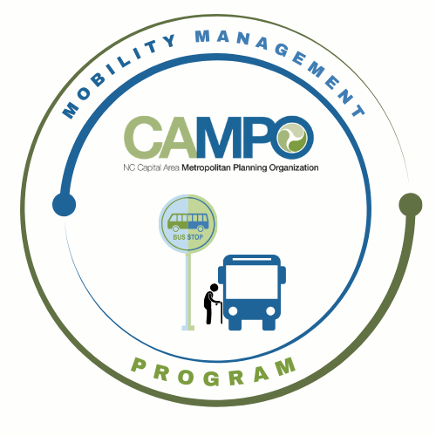
Mobility Coordination Committee (MCC)
CT Sub-committee Meeting Friday, May 22, 2026 – 11:00 am – 12:30 pm

Coordinated Public Transit - Human Services Transportation Plan

CT Meeting Agenda

- Welcome/ Introductions/Attendance – Anita Davis, CT Sub-Committee Chair

- Meeting Minutes– Anita Davis, CT Sub-Committee Chair

- Action Item Recap – Anita Davis, CT Sub-Committee Chair

  - April Meeting Recap
  - Updated Assessment Sheets with new goals
  - Public Input – Meeting in June to discuss

- Implementation Schedule –Anita Davis, CT Sub-Committee Chair
- Review Schedule to create January – December 6-month Work Plan
  - Goal: Review Work tasks (3)
3.2.6 Identify dedicated funding mechanisms for rural transit agencies.
3.2.7 Expand service hours and days in rural areas as warranted.
3.2.8 Continue to expand public transportation access in eastern Wake County

- Mobility Coordination/Management Program Updates – Sarah Keach, MM
- Presentation at NCAMPO
- Announcements - Anita Davis, CT Sub-Committee Chair
- Action Items for Next Meeting:
- Next meetings:

MCC CT Subcommittee Meeting: Friday, June 12th, 2026 11:00pm – 12:30pm
MCC ADA Subcommittee Meeting: Friday, June 12th, 2026 9:30am – 11am
MCC Quarterly Meeting: TBD

