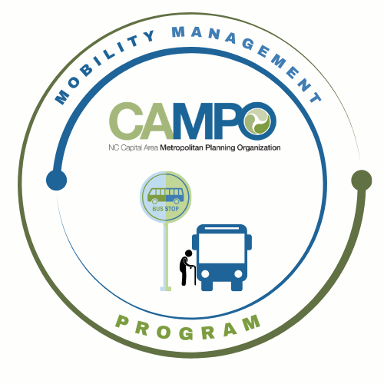
Mobility Coordination Committee (MCC)
ADA Sub-committee Meeting Friday, May 22, 2026 – 9:30 am – 11:00am

Coordinated Public Transit - Human Services Transportation Plan

ADA Meeting Minutes

ADA Meeting Agenda

- Welcome/ Introductions/ Attendance / Recording – Sheri Legans, ADA Sub-Committee Chair
Sheri Legans (GoCary), Sarah Keach, Jacob Irving, Suvir Venkatesh (CAMPO), Natalie Wilson, Paris Butler (GoWake), Pamela Bennett (HARTS), Katie Schwing (GoApex), Randy Cantor (KARTS), Chris Baucom (ADA), Chris Clark, Rico Greene, Tammy Romain (GoTriangle), Sean Abrams (GoRaleigh)
- Meeting Minutes
Notes on the ADA matrix have been used for the meeting minutes.
- Discussion / Work Session - Sheri Legans, Chair
  - 2.1.1 – Explore opportunities to streamline ADA application language and processes
  - 2.1.2 – Coordinate no-show/late cancellation policies
- Announcements - Sheri Legans, ADA Sub-Committee Chr
  - Action Items for Next Meeting:
    - Review draft discussion document sent by Katie
    - Sarah to send FTA no show/late policies
  - Next meetings:
MCC ADA Subcommittee Meeting: Friday, June 12th, 2026 9:30am
MCC CT Subcommittee Meeting: Friday, June 12th, 2026 11:00am
1 Fenton Main Street, Suite 201 Cary, NC 27511 | Phone: (984) 542-3602| www.campo-nc.us
Full MCC Meeting: TBD

