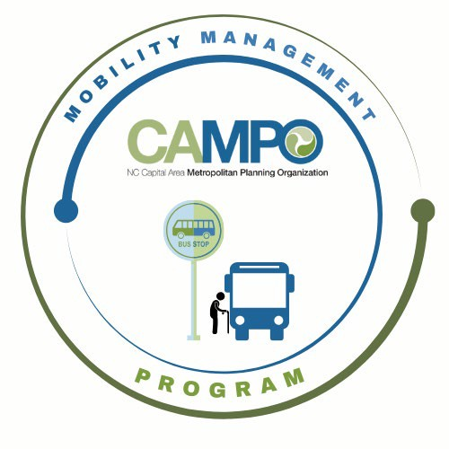
NowMeeting
MOBILITY COORDINATION COMMITTEE (MCC)
Coordinated Public Transit - Human Services Transportation Plan

ADA Meeting Agenda
- Welcome/ Introductions/ Attendance / Recording – Sheri Legans, ADA Sub-Committee Chair
- Discussion / Work Session - Sheri Legans, Chair
  - 2.1.1 – Explore opportunities to streamline ADA application language and processes
  - 2.1.2 – Coordinate no-show/late cancellation policies
- Announcements - Sheri Legans, ADA Sub-Committee Chr
  - Action Items for Next Meeting:
    - Review draft discussion document sent by Katie
  - Next meetings:
MCC ADA Subcommittee Meeting: Friday, April 3, 2026 1:30pm
MCC CT Subcommittee Meeting: Friday, April 3, 2026 3:00pm
1 Fenton Main Street, Suite 201 Cary, NC 27511 | Phone: (984) 542-3602| www.campo-nc.us
Full MCC Meeting: Thursday, April 16, 2026 1:30pm

