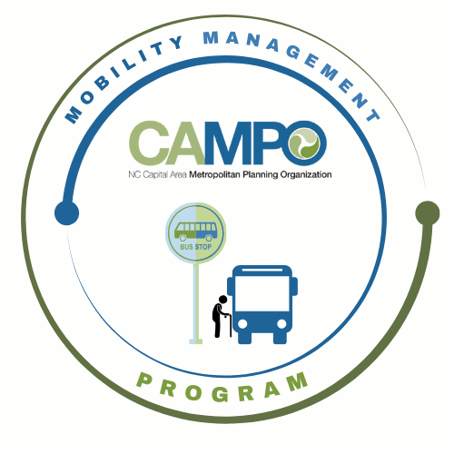
Mobility Coordination Committee (MCC) CT Subcommittee Meeting Wednesday, March 5, 2025 - 10:30 a-11:30 a
Join the meeting now
Meeting ID: 281 361 771 809
Passcode: qC3aZ2fa

Coordinated Public Transit - Human Services Transportation Plan

CT Meeting Agenda

- Welcome/ Introductions/Attendance – Anita Davis, CT Sub-Committee Chair (2 mins)

- Previous Meeting Minutes/Adjustments – Anita Davis, CT Sub-Committee Chair (2 mins)

- Implementation Schedule CT Review - Anita Davis, CT Chair/Crystal Odum MCC Administrator, (10 mins)

Requested Action: Information.

- January-June 6 mos. CT Task List Review of 3.2.5 Goal Update- Anita Davis, CT Sub-Committee Chair, (5 mins)

Requested Action: Information.

- Materials/information List for Discussions/Work – Anita Davis, CT Sub-Committee Chair (29 mins)

        - Latest MicroTransit/Transit regional Feasibility Studies
        - Existing/Pending MicroTransit Services
        - Feasibility of Social Pinpoint Pilot Program w/Eastern Wake Regional Center

Requested Action: Discussion

- Mobility Coordination/Management Program Updates – Sarah Williams, MM (10 mins)

        - Agencies Communications Plans
        - Agencies Existing Transit Marketing/Outreach Plans/Efforts/Contact Persons
        - Western Wake Regional Center Pilot Program Opportunity

Requested Action: Information

- Announcements – Anita Davis, CT Sub-Committee Chair, (2 min)
- Action Items
- Next meetings are on Friday, April 4, 2025 at 2:30 pm and the Full MCC Meeting is on Thursday April 17th at **2 pm.- (New time to accommodate WT sub-committee meeting)

