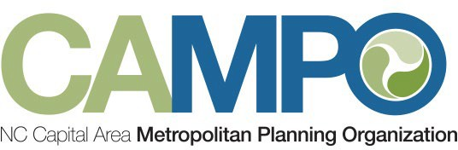

To: Mobility Coordination Committee (MCC) Members

From: Sarah Keach, CAMPO Mobility Manager

Subject: Mobility Coordination Committee Quarterly Update
The overarching goal of the Mobility Coordination Committee is to coordinate transportation services between regional transit providers and human service agencies while implementing the goals of the latest Coordinated Public Transit-Human Services Transportation Plan and the Regional Mobility Management Program.

The last Quarterly MCC Meeting took place on October 9th, 2025. Following that meeting, the MCC Administrator developed an Implementation Schedule Assessment Sheet which provides status updates on each goal from the Coordinated Plan. The Assessment Sheets are attached to the Implementation Schedule and separated by goal for each subcommittee. The Assessment Sheets are to be filled out by the MCC Administrator quarterly.

The Community Transportation (CT) Subcommittee spent time completing Assessment Sheets for completed July to December 6-month goals, which include Goal 3.2.1 Expand Wake Tech to Ten-Ten and Kildaire Farm Rd., Goal 3.2.2 Expand Morrisville Smart Shuttle, and Goal 3.2.3 Conduct efficiency KARTS study. Goal 3.2.4 Explore Microtransit in Clayton is still on-going. The CT Subcommittee also researched data capturing services like Red Cap to continue with Goal 1.1.1 Consider feasibility of Social Pinpoint Data Collection Pilot Program. Ultimately, it was recommended that the MCC does not move forward with Red Cap, but there was discussion about Public Input and how that may be another avenue to explore.

The ADA Subcommittee lead transit agencies developed an ADA Services Matrix and held additional meetings outside of the MCC subcommittee meetings to review and discuss current services. The participating agencies are GoWake Access, GoRaleigh Access, GoApex, GoTriangle, and GoCary. The matrix includes questions about eligibility requirements, no-show/late cancellation policies, and other current services. The matrix was completed January 2026. It will be reviewed to determine gaps, overlaps, and opportunities for coordination in the coming ADA Subcommittee meetings.

The CAMPO Mobility Manager presented on the Mobility Management Program Communications Plan to the TCC and Executive Board in November 2025 and began implementation. The Mobility Manager will begin an in-depth supply and demand assessment beginning January 2026 to be completed in June 2026. This will require working closely with MCC transit and human service agencies to gather pertinent data. The Mobility Manager will be reaching out to schedule meetings.

The next Quarterly Mobility Coordination Committee Meeting is on Thursday, April 16th, 2026 at 1:30pm.

