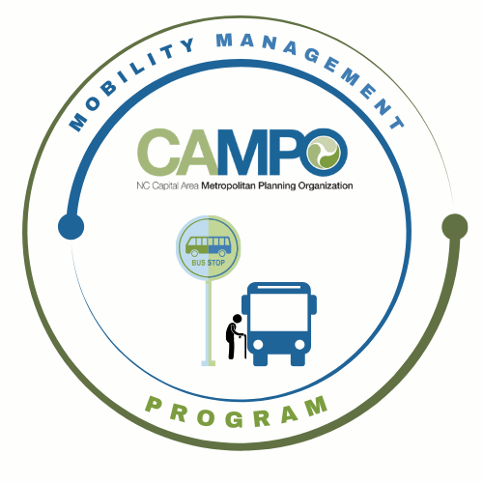
Mobility Coordination Committee (MCC)
CT Subcommittee Meeting Wednesday, June 10, 2026 – 11:00 am – 12:30 pm

Coordinated Public Transit - Human Services Transportation Plan

CT Meeting Minutes

- Welcome/ Introductions/Attendance – Anita Davis, CT Subcommittee Chair
Anita Davis, Paris Butler, Natalie Wilson (GoWake Access), Sarah Keach, Steven Mott, Suvir Venkatesh, Stephanie Plancich, (CAMPO), Josh Jensen, Neal Davis (JCATS), Chance Torain (HARTS), Randy Cantor (KARTS), Chris Baucom (ADA), Chris Clark (GoTriangle)

- Meeting Minutes– Anita Davis, CT Subcommittee Chair

Approved

- Action Item Recap – Anita Davis, CT Subcommittee Chair

JCATS sent survey data to Natalie. They do not have a formal transit feasibility study, but there have been discussions about expansion based on feedback from town leadership and the community. There has been turn over of the Town Planner position in Clayton, so the microtransit discussion has been delayed.

GoRaleigh and GoTriangle were asked to provide survey data that helps justify expansions.

Survey data is to collect information and decide to use it for best practices or recommendations.

- Wake Transit Bus Plan Presentation – Steven Mott, Senior Wake Transit Planner

Presentation is attached to this document.

The Wake Transit team is seeing an MCC focus group for Phase 1 Engagement.

Steven provided background information and an overview of the Wake Transit Bus Plan and how it works together with the CPT-HSTP in helping to serve seniors, people with disabilities, and low income individuals. Steven discussed the overall project schedule which kicked off earlier this year and Phase 1 Engagement is launching July 20th, 2026. The technical work on policies, service standards, and short range transit plans are shown in the schedule. Draft recommendations will be coming out in the fall and leading to final plan adoption by June 2027.

The digital launch of the Public Engagement will be July 20th, 2026 and in person events will start in August 10th, 2026 through September 7th, 2026. Digital launch will have an online survey, website, social content, and partner tool kit. In person engagement includes up to 3 in person sessions and up to 3 virtual sessions with one offered in Spanish. Pop up events are at ridership locations and all materials will be provided in English and Spanish.

Four goals have been identified in Phase 1
- Prioritization Policy
  - Help public understand how bus investments are evaluated and prioritized within the WTP framework
- WTP Service Priorities
  - Get feedback on the refined bus service concepts informed by WTP priorities
- Mobility Hubs
  - Understand where mobility hubs are needed and what factors should guide future hub locations and investments
- Access to Transit
  - Understand first/last mile barriers and identify ways to improve connections and transfer opportunities

Steven provided a QR Code to a poll that the MCC can fill out to meet for a focus group.

Anita suggested WT team do a presentation for the Western Regional CAC meetings.

- Implementation Schedule –Anita Davis, CT Subcommittee Chair

  - Updates
    - Goal 3.2.6 - Subcommittee will continue to research and monitor rural transit funding as needed.
    - Goal 3.2.7 - Subcommittee will evaluate survey data and justifications for rural service expansions.
      - How does committee want to use information
        - Best practices
        - Recommendations
    - Goal 3.2.8 - Subcommittee will continue to monitor demand and needs of eastern Wake.
  - Choose three new FY27 July – December Goals
    - 3.3.1 Explore the need for a Lyft/Uber voucher or subsidy program to address the needs of vulnerable populations & 4.1.1 Prepare informational materials targeted to decision-makers and stakeholders regarding the benefits of public transportation, including mobility programs for seniors and persons with disabilities (Combined these two goals together)
    - 3.3.2 Increase access to volunteer driver programs
    - 4.1.3 Ensure transit vehicles are effectively accessible to enhance ease of travel

- Mobility Coordination/Management Program Updates – Sarah Keach, MM
- What do transit agencies need for funding
  - What types of projects?

- Announcements - Anita Davis, CT Subcommittee Chair
- Action Items for Next Meeting:
- ALL MCC CT MEMBERS - fill out focus group poll to provide feedback on Wake Transit Bus Plan - MCC Focus Group - Wake Bus Plan 2035 (Poll for CT Subcommittee Meeting) - LettuceMeet
- Anita Davis/Stephanie Plancich - Coordinate with Western Regional Center Transportation Action Group and other regional centers to provide Bus Plan information and materials.
- Sarah Keach - Update Implementation Schedule to reflect new goals.

- Next meetings:

MCC CT Subcommittee Meeting: July 1st, 2026 11-12:30
MCC ADA Subcommittee Meeting: July 1st, 2026 9:30-11
Full MCC Meeting: Thursday, July 9th, 2026 1:30pm

