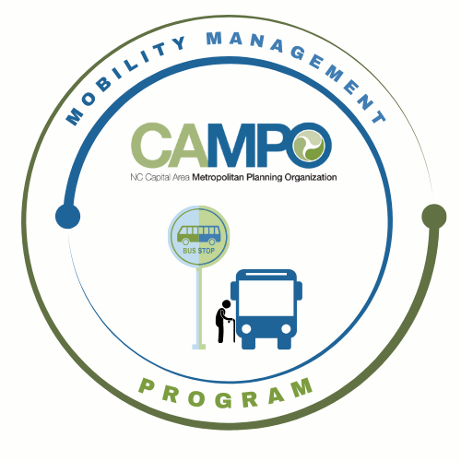
Mobility Coordination Committee (MCC)
CT Subcommittee Meeting Friday, May 22, 2026 – 11:00 am – 12:30 pm

Coordinated Public Transit - Human Services Transportation Plan

CT Meeting Agenda

- Welcome/ Introductions/Attendance – Anita Davis, CT Subcommittee Chair

- Meeting Minutes– Anita Davis, CT Subcommittee Chair

- Action Item Recap – Anita Davis, CT Subcommittee Chair

- Transit Agencies - GoRaleigh, GoCary, GoTriangle, JCATS, HARTS -Please send Sarah Keach your ADA service area shapefiles if you have not already done so.
- GoRaleigh, GoTriangle, JCATS - Please send Natalie Wilson any relevant survey data about service expansions or studies that justify expansions.

- Wake Transit Bus Plan Presentation – Steven Mott, Senior Wake Transit Planner
  - Project overview and schedule
  - Overview of the MCC role in Wake Bus Plan development
  - Meeting Poll for MCC focus group

- Implementation Schedule –Anita Davis, CT Subcommittee Chair

  - Updates
    - Goal 3.2.6 - Subcommittee will continue to research and monitor rural transit funding as needed.
    - Goal 3.2.7 - Subcommittee will evaluate survey data and justifications for rural service expansions.
      - How does committee want to use information
        - Best practices
        - Recommendations
    - Goal 3.2.8 - Subcommittee will continue to monitor demand and needs of eastern Wake.
  - Choose three new FY27 July – December Goals

- Mobility Coordination/Management Program Updates – Sarah Keach, MM
- Ridership data from ITRE
- What do transit agencies need for funding
  - What types of projects?

- Announcements - Anita Davis, CT Subcommittee Chair
- Action Items for Next Meeting:
- Next meetings:

MCC CT Subcommittee Meeting: July 1st, 2026 11-12:30
MCC ADA Subcommittee Meeting: July 1st, 2026 9:30-11
Full MCC Meeting: Thursday, July 9th, 2026 1:30pm

