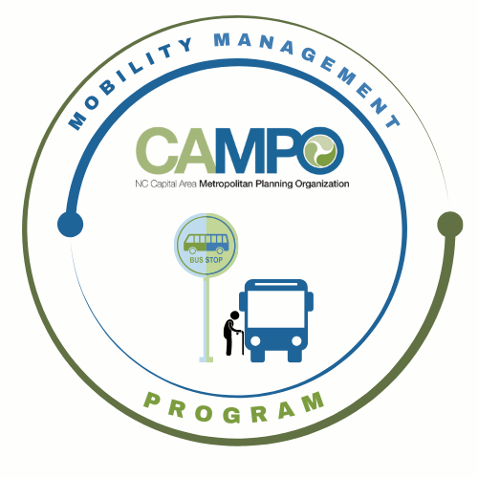
Mobility Coordination Committee (MCC)
ADA Subcommittee Meeting Wednesday, June 10, 2026 – 9:30 am – 11:00 am

Coordinated Public Transit - Human Services Transportation Plan

ADA Meeting Minutes

- Welcome/ Introductions/ Attendance / Recording – Sarah Keach, Mobility Manager
Sarah Keach (CAMPO), Paris Butler, Natale Wilson (GoWake Access), Chance Torain (HARTS), Katie Schwing (GoApex), Tammy Romain, Rico Greene (GoTriangle), Dana Smith (GoRaleigh), Chris Baucom (ADA)
- Meeting Minutes
Sent after meeting along with ADA 2.1.1, 2.1.2 Action Items 2026 Draft and Draft Discussion Items – 2.1.1 and 2.1.2 next steps – MCC ADA subcommittee Document

- Discussion / Work Session – Sarah Keach, Mobility Manager
Sheri was unable to attend June meeting. There was discussion about how the MCC needed to review the Action Items and Discussion Items prior to the next meeting. Many of the items on these documents are individual agency items instead of group discussion items. It is important that each agency review the documents. Additionally, the subcommittee is to review the FTA no-show and late cancellation policies.
Discussion about creating the new July – December 2026 Work Plan to be created in July 2026 meeting.
There was a presentation during the CT subcommittee meeting that ADA members were encouraged to attend.
- Announcements - Sheri Legans, ADA Sub-Committee Chr
  - Action Items for Next Meeting:
    - Review:  ADA Subcomm_2.1.1_2.2.1 Action Items_2026_Draft.docx
    - Draft Discussion items - 2.1.1 and 2.1.2 next steps - MCC ADA subcommittee.docx
    - FTA C 4710.1
      - 9.12 No-Show Suspensions (pg. 245)
      - 9.12.1 - Late Cancellations
        - https://www.transit.dot.gov/sites/fta.dot.gov/files/docs/Final_FTA_ADA_Circular_C_4710.1.pdf

    - 2026 Triennial Review Contractor Manual
    - Section 13, Page 478
      - https://www.transit.dot.gov/sites/fta.dot.gov/files/2025-12/Fiscal-Year-2026-Contractor-Manual.pdf

  - Next meetings:
MCC ADA Subcommittee Meeting: Wednesday July 1st, 2026 9:30am
MCC CT Subcommittee Meeting: Wednesday, July 1st, 2026 11:00am
1 Fenton Main Street, Suite 201 Cary, NC 27511 | Phone: (984) 542-3602| www.campo-nc.us
Full MCC Meeting: Thursday, July 9th, 2026 1:30pm

