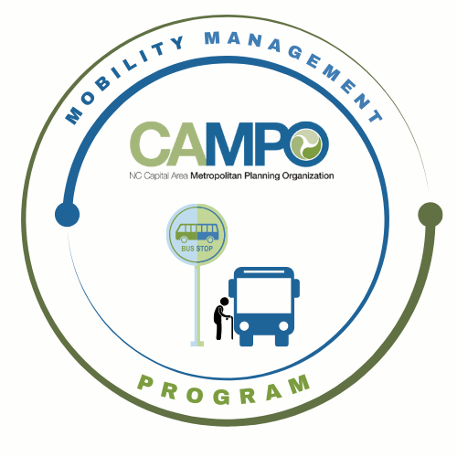
Mobility Coordination Committee (MCC)
ADA Sub-committee Meeting Wednesday, June 10, 2026 – 9:30 am – 11:00 am

Coordinated Public Transit - Human Services Transportation Plan

ADA Meeting Agenda

ADA Meeting Agenda

- Welcome/ Introductions/ Attendance / Recording – Sheri Legans, ADA Sub-Committee Chair
- Meeting Minutes

- Discussion / Work Session - Sheri Legans, Chair
  - 2.1.1 – Explore opportunities to streamline ADA application language and processes
    - Finalize recommendations
  - 2.1.2 – Coordinate no-show/late cancellation policies
    - Review matrix and FTA reference materials
    - Develop and finalize recommendation list
- Announcements - Sheri Legans, ADA Sub-Committee Chr
  - Action Items for Next Meeting:
    - Review and finalize July – December 2026 Work Plan
  - Next meetings:
MCC ADA Subcommittee Meeting: Wednesday July 1st, 2026 9:30am
MCC CT Subcommittee Meeting: Wednesday, July 1st, 2026 11:00am
1 Fenton Main Street, Suite 201 Cary, NC 27511 | Phone: (984) 542-3602| www.campo-nc.us
Full MCC Meeting: Thursday, July 9th, 2026 1:30pm

