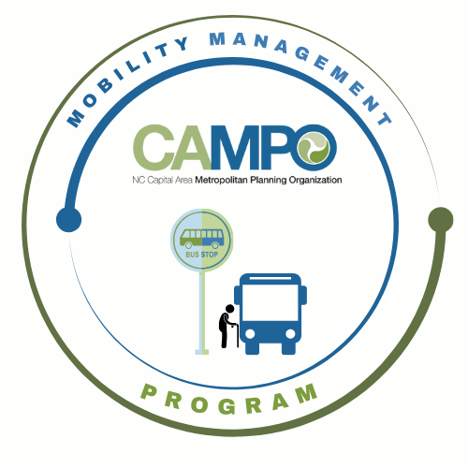
Coordinated Public Transit - Human Services Transportation Plan

CT Meeting Minutes

- Welcome/ Introductions/Attendance – Anita Davis, CT Sub-Committee Chair

- Previous Meeting Minutes Adjustments – Anita Davis, CT Sub-Committee Chair
No adjustments to the meeting minutes.

- Implementation Schedule –Anita Davis, CT Sub-Committee Chair
- July - December 6 mos. - Work Program
  - MCC Members identified 3 new goals for the next 6 months.
- 3.2.6 Identify dedicated funding mechanisms for rural transit agencies
- 3.2.7 Expand service hours and days in rural areas as warranted
- 3.2.8 Continue to expand public transportation access in eastern Wake

- Action Items Follow up – Anita Davis, CT Sub-Committee Chair (20 mins)
- Update Assessment Sheets
  - Provide updates on Work Task
    - Previous assessment sheets have been updated and completed.
- Red Cap pilot follow up discussion
  - It was decided that Red Cap would not move forward at this time and Public Input would be explored.

- Mobility Coordination/Management Program Updates – Sarah Keach, MM (15 mins)
  - Sarah provided an overview of the supply and demand assessment.

- Announcements - Anita Davis, CT Sub-Committee Chair, (2 min)
- Action Items for Next Meeting:
    - Review work task list

