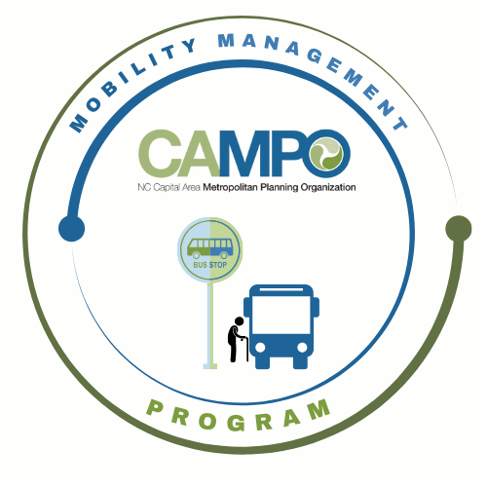
Coordinated Public Transit - Human Services Transportation Plan

CT Meeting Agenda

- Welcome/ Introductions/Attendance – Anita Davis, CT Sub-Committee Chair (3 mins)

- Previous Meeting Minutes Adjustments – Anita Davis, CT Sub-Committee Chair (3 mins)

- Implementation Schedule –Anita Davis, CT Sub-Committee Chair/ Crystal Odum, MCC Administrator (35 mins)
A) July - December 6 mos. - Work Program
B) 5310 Program Update - Comments on the November 2025 Draft PMP due by Dec 11th

- Action Items Follow up – Anita Davis, CT Sub-Committee Chair (20 mins)
- Update Assessment Sheets
  - Provide updates on Work Task
- Red Cap pilot follow up discussion
- Ask agencies what they are using for data collection currently
  - Discuss what JCATS sent for data collection
  - CAMPO – PublicInput
  - GoWake Access
  - HARTS

- Mobility Coordination/Management Program Updates – Sarah Keach, MM (15 mins)
  - Overview / Supply and demand assessment
  - Share ideas with Sarah about tabling and outreach efforts
  - Share data ideas with Sarah

- Announcements - Anita Davis, CT Sub-Committee Chair, (2 min)
- Action Items for Next Meeting:
- Next meetings:

MCC CT Subcommittee Meeting: Wednesday, January 7th, 2026 11am
MCC ADA Subcommittee Meeting: Wednesday, January 7th, 2026 9:30am

