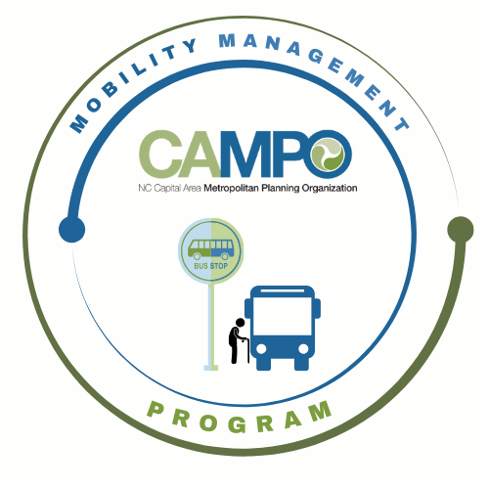
Mobility Coordination Committee (MCC) CT Subcommittee Meeting Friday, February 7, 2025 - 2:30-3:30 p
Join the meeting now
Meeting ID: 262 594 510 626
Passcode: C5oP9xP2

Coordinated Public Transit - Human Services Transportation Plan

CT Meeting Agenda

- Welcome/ Introductions/Attendance – Anita Davis, CT Sub-Committee Chair (2 mins)

- Previous Meeting Minutes Adjustments – Anita Davis, CT Sub-Committee Chair (1 min)

- Detailed Implementation Schedule CT Review - Anita Davis, CT Sub-Committee Chair, (15 mins)

Requested Action: Discussion.

- January-June 6 mos. CT and MM Work Task Lists Review - Anita Davis, CT Sub-Committee Chair, (20 mins)

Requested Action: Discussion. Approve CT Sub-committee 6 mos Work Task List

- Develop Materials/information List for Discussions/Work – Anita Davis, CT Sub-Committee Chair (11 mins)

        - Latest MicroTransit/Transit regional Feasibility Studies
        - Existing/Pending MicroTransit Services
        - Feasibility of Social Pinpoint Pilot Program w/Eastern Wake Regional Center

Requested Action: Brainstorming. Note list of needed items/future action items and Discussion

- Mobility Coordination/Management Program Needs/Opportunities – Sarah Williams, MM (10 mins)

        - Agencies Communications Plans
        - Agencies Existing Transit Marketing/Outreach Plans/Efforts/Contact Persons
        - Western Wake Regional Center Pilot Program Opportunity

Requested Action: Brainstorming. Note list of needed items/future action items and Discussion

- Announcements – Anita Davis, CT Sub-Committee Chair, (1 min)
- Action Items
- Next meeting is on Wednesday, March 5, 2025 at 10:30 am.

