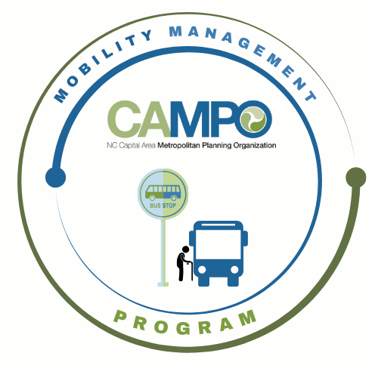
Mobility Coordination Committee (MCC) CT Subcommittee Meeting Friday, February 7, 2025 - 2:30-3:30 p

ADD Virtual info
Coordinated Public Transit - Human Services Transportation Plan

Meeting Agenda

- Welcome/ Introductions/Attendance – Sheri Legans, MCC ADA Sub-Committee Chair (1 min)

- Previous Meeting Minutes Adjustments – Sheri Legans, MCC ADA Sub-Committee Chair (1 min)

- Draft Detailed Implementation Schedule Review - Sheri Legans, MCC ADA Sub-Committee Chair (15 mins)

Requested Action: Discussion.

- January-June 6 mos. ADA and MM Work Task Lists - Sheri Legans, MCC ADA Sub-Committee Chair (20 mins)

Requested Action: Discussion. Approve ADA work task list.

- Develop Materials/information Needed for Discussions/Work - Sheri Legans, ADA Sub-Committee Chair (22 mins)

      - Draft regional ADA service area map
      - Review/confirmation of existing agency ADA service maps
      - Collection/Review of existing agency ADA Paratransit Service agreements
        - GoTriangle and GoRaleigh One-Seat Trip Agreement

Requested Action: Brainstorming and Discussion

- Announcements – (Sheri Legans, MCC ADA Sub-Committee Chair, 1 min)
- Action Items for Next meeting
- Next meeting is on Wednesday, March 5, 2025 at 9:30 am.

