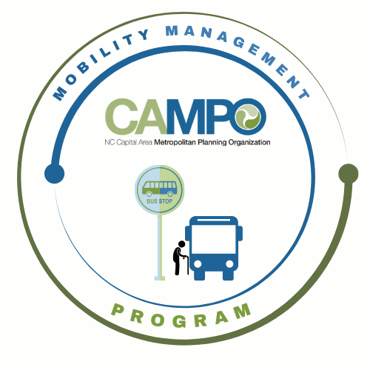
Coordinated Public Transit - Human Services Transportation Plan

CT Meeting Minutes

- Welcome/ Introductions/Attendance – Anita Davis, CT Sub-Committee Chair
Sarah Keach, Suvir Venkatesh, Bonnie Parker, Stephanie Plancich, Jacob Irving (CAMPO), Anita Davis, Paris Butler, Natalie Wilson (GoWake Access), Sean Abrams (GoRaleigh), Neal Davis, Josh Jensen (JCATS), Sheri Legans (GoCary), Rico Greene (GoTriangle), Chris Baucom (ADA)

Staff introduction: Natalie Wilson from GoWake Access

- Task Recap – Anita Davis, CT Sub-Committee Chair
- Follow up on Task 3.2.5 – Explore opportunities to increase service capacity by adding vehicles
  - GoWake Access would not be adding additional vehicles to the fleet. Instead, they will be trading old fleet out for a new fleet, but additional vehicles will not be added.
  - GoRaleigh will also be trading out old vehicles for new ones, but will not be adding any additional vehicles to the fleet.
  - GoCary believes they will be adding additiona vehicles, but needs to confirm
  - GoTriangle will be replacing old vehicles with new ones, but not adding additional.
  - JCATS is approved for 11 new vehicles this year. 5 have been ordered, but is waiting for the others to be ordered due to red tape. 6 vehicles will be EV.
  - Taks considered complete.
- Provide an update on Western Wake Feasibility Pilot and Mobility hub
  - Working with a non-profit as a part of Dorcas Ministries and Western wake to try to apply for a grant
- Update the assessment sheets
  - All have previously been updated to completed

- Discussion – Public Input for data capturing – Bonnie Parker, Public Engagement and Communications Planner
- Want to capture data for regional centers to see if people are utilizing transportation services and ways we can provide more outreach
- Bonnie gave an overview of Public Input and the ways CAMPO uses it for capturing data
- Looking into using it for the MCC
- Another meeting to follow

- Implementation Schedule –Anita Davis, CT Sub-Committee Chair
- Review Schedule to create January – June 6-month Work Plan
3.2.6 Identify dedicated funding mechanisms for rural transit agencies.
3.2.7 Expand service hours and days in rural areas as warranted.
3.2.8 Continue to expand public transportation access in eastern WakeCounty.

- Mobility Coordination/Management Program Updates – Sarah Keach, MM
  - Supply and Demand Assessment

- Announcements - Anita Davis, CT Sub-Committee Chair,
- Action Items for Next Meeting:
    - Update assessment sheets
    - Sarah to update workplan for 6 months
    - Send shape files
    - Set up meeting with Bonnie/WT Team on more info on Public Input
- Next meetings:

MCC CT Subcommittee Meeting: Wednesday, March 4, 2026 11am
MCC ADA Subcommittee Meeting: Wednesday, March 4, 2026 9:30am

